DATA BASE PROJECT

**ID:3075494**

**Sai Krishna Kovi**

**12 . VIEWS**

**12a.EMPLOYEE_INFO**

**QUERY :**

CREATE OR REPLACE VIEW EMPLOYEE_INFO AS

SELECT A.FIRST_NAME||' '||A.MIDDLE_NAME ||' '||A.LAST_NAME AS EMPLOYEENAME,A.STREET_ADDRESS ADDRESS,

A.HOME_PHONE_NUMBER HOMEPHONE,A.CELL_PHONE_NUMBER CELLPHONE,

A.ZIP_CODE ZIPCODE,A.SSN SSN,A.SALARY SALARY,A.BIRTH_DATE BDATE,

TRUNC(MONTHS_BETWEEN(SYSDATE,A.BIRTH_DATE)/12) AGE,

A.MARITAL_STATUS MARITALSTAT,A.SPOUSE_NAME SPOUSNAME,B.OFFICE_ID OFFICEID,A.LAST_DEGREE LASTDEG,A.DATE_DEGREE DEGDATE,C.GENERAL_MGR_ID GMID

FROM PROJECT.EMPLOYEE A, PROJECT.OFFICE_EMPLOYEE B,PROJECT.OFFICE_GENERAL_MANAGER CELLPHONEWHERE A.EMPLOYEE_ID AND B.OFFICE_ID=C.OFFICE_ID

/

SELECT *FROM EMPLOYEE_INFO

**Output:**

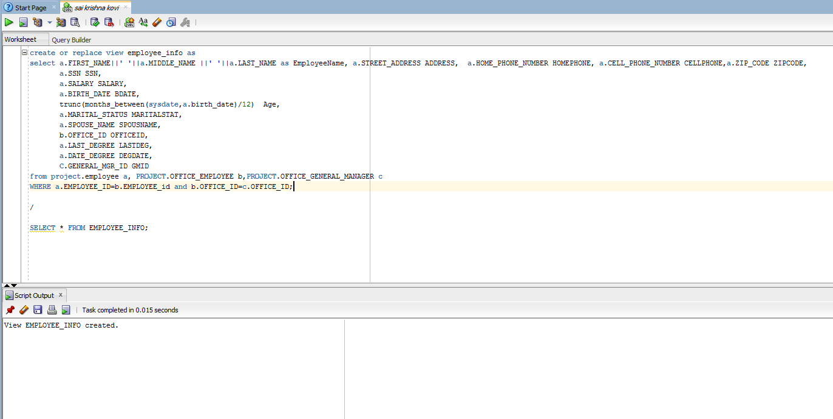

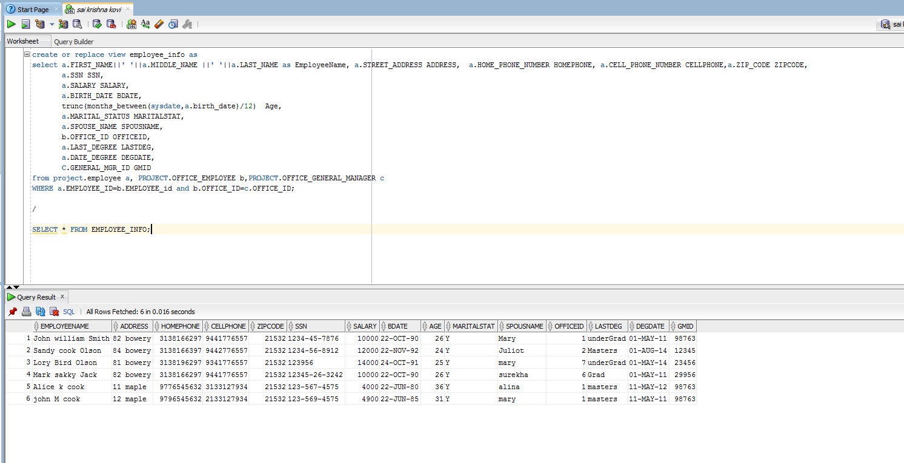

**12b.EMPLOYEE_SALARY**

**Query:**

**CREATE OR REPLACE VIEW EMPLOYEE_SALARY AS**

**SELECT A.FIRST_NAME,A.LAST_NAME,A.SSN,A.STREET_ADDRESS||' '||CITY||' '||STATE||' '||ZIP_CODE AS ADDRESS,A.SALARY,A.TAX_DEDUCTION,A.MARITAL_STATUS,**

**B.OFFICE_ID**

**(SELECT MAX(SALARY) MAX_SAL FROM PROJECT.EMPLOYEE) MAXIMUM_SAL,**

**(SELECT ROUND(AVG(SALARY)) AVG_SAL FROM PROJECT.EMPLOYEE) AVERAGE_SAL**

**FROM PROJECT.EMPLOYEE A ,PROJECT.OFFICE_EMPLOYEE B WHERE A.EMPLOYEE_ID=B.EMPLOYEE_ID;**

**SELECT *FROM EMPLOYEE_SALARY;**

**Output:**

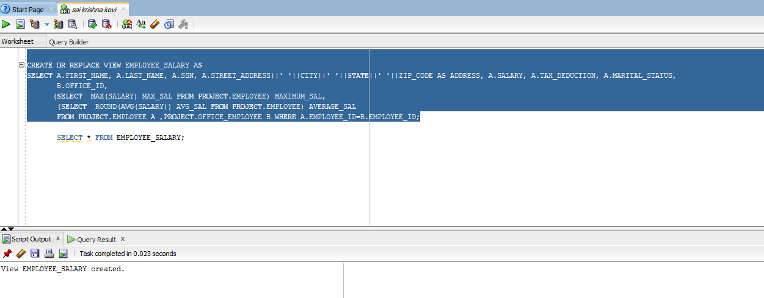

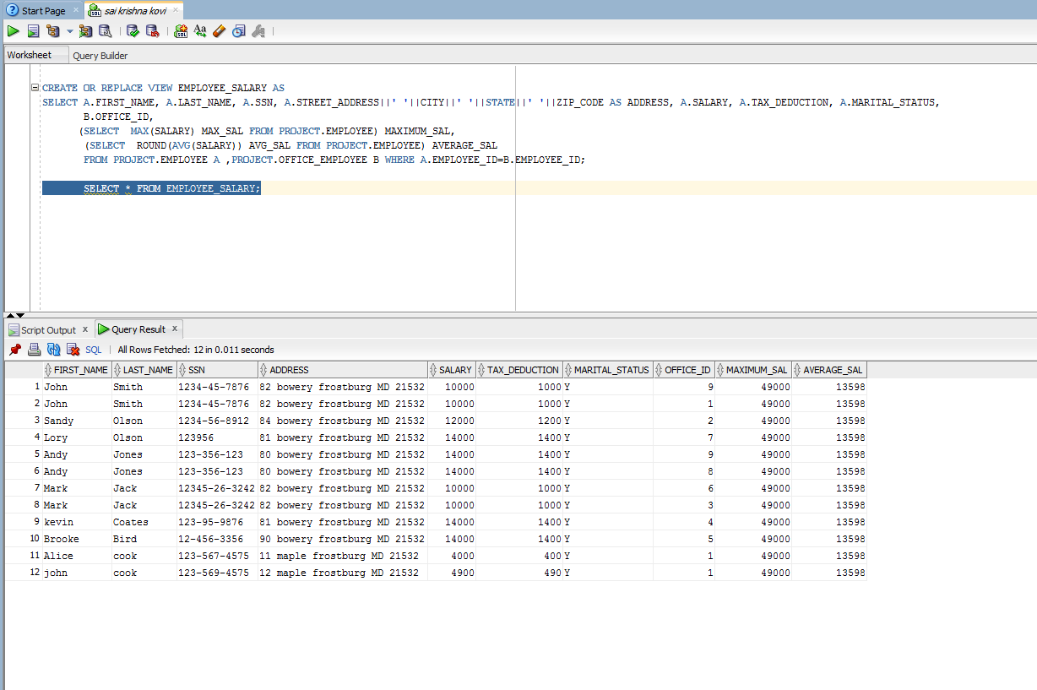

**12C BRANCH_INFO**

**Query:**

**create or replace view branch_info as**

**select A.office_id,A.ADDRESS,A.PHONE_NUMBER,A.FAX_NUMBER,B.REGULAR_OPEN_HOURS,C.BUSINESS_OPEN_DAY,D.GENERAL_MANAGER, D.DATE_HIRED**

**from PROJECT.OFFICE A,PROJECT.OFFICE_TIMINGS B,PROJECT.OFFICE_DAY C,PROJECT.OFFICE_GENERAL_MANAGER D**

**WHERE A.OFFICE_ID=B.OFFICE_ID AND A.OFFICE_IC.OFFICE_ID AND A.OFFICE_ID=D.OFFICE_ID**

**SELECT *FROM BRANCH_INFO;**

**OUTPUT:**

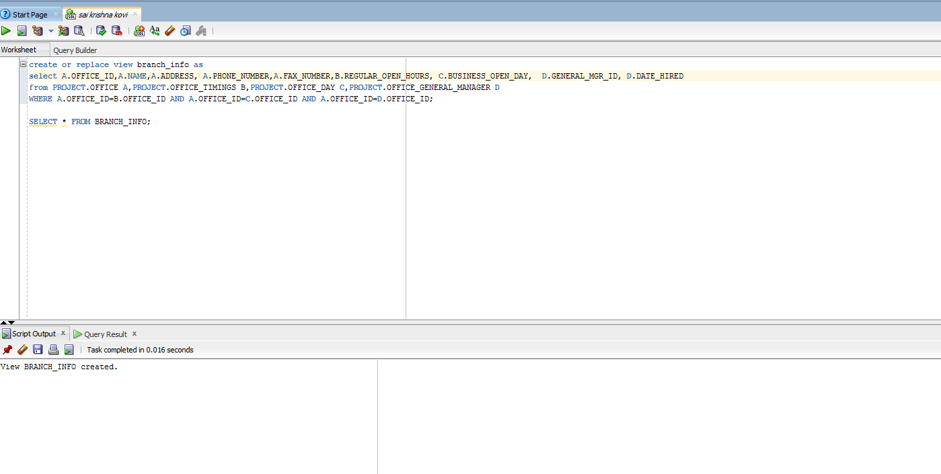

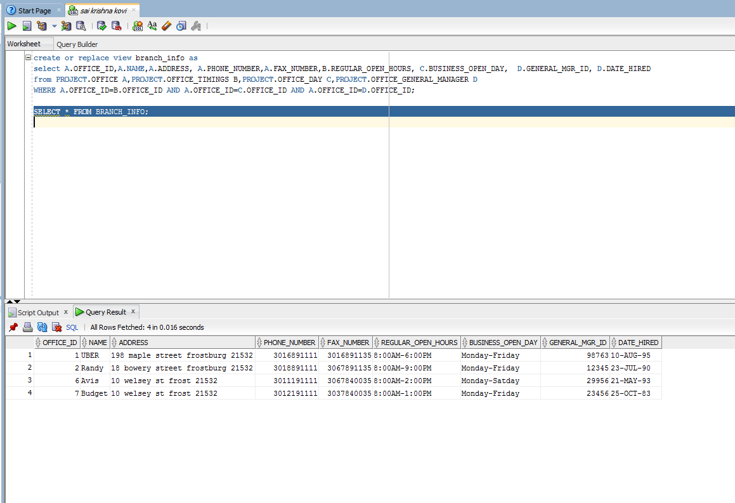

**12D.VALUED_CUSTOMER**

**Query:**

**CREATE OR REPLACE VIEW VALUED_CUSTOMER AS**

**SELECT A.FIRST_NAME||' 'A.LAST_NAME AS NAME,A.STREET_ADDRESS||' '||CITY||' '||STATE AS ADDRESS, To_char(BIRTH_DATE,'YYYY')AS AGE,**

**A.CELL_PHONE CL_PHONE,**

**A.ZIP_CODE zpcode,**

**A.EMAIL emil,A.LICENCE_NUMBER LCNUM,A.LICENSE_ISSUED_STATE lc_ISS_STATE,**

**(SELECT COUNT(*)FROM PROJECT.CAR_CUSTOMER_RENT GROUP BY CUSTOMER_ID HAVING COUNT(*) >=4)COUNTFROM PROJECT.CUSTOMER A WHERE (select count from(SELECT customer_id,count(*) count FROM PROJECT.CAR_CUSTOMER_RENT GROUP BY CUSTOMER_ID )where customer_id=a.customer_id)>=4**

**select *from valued_customer;**

**Output:**

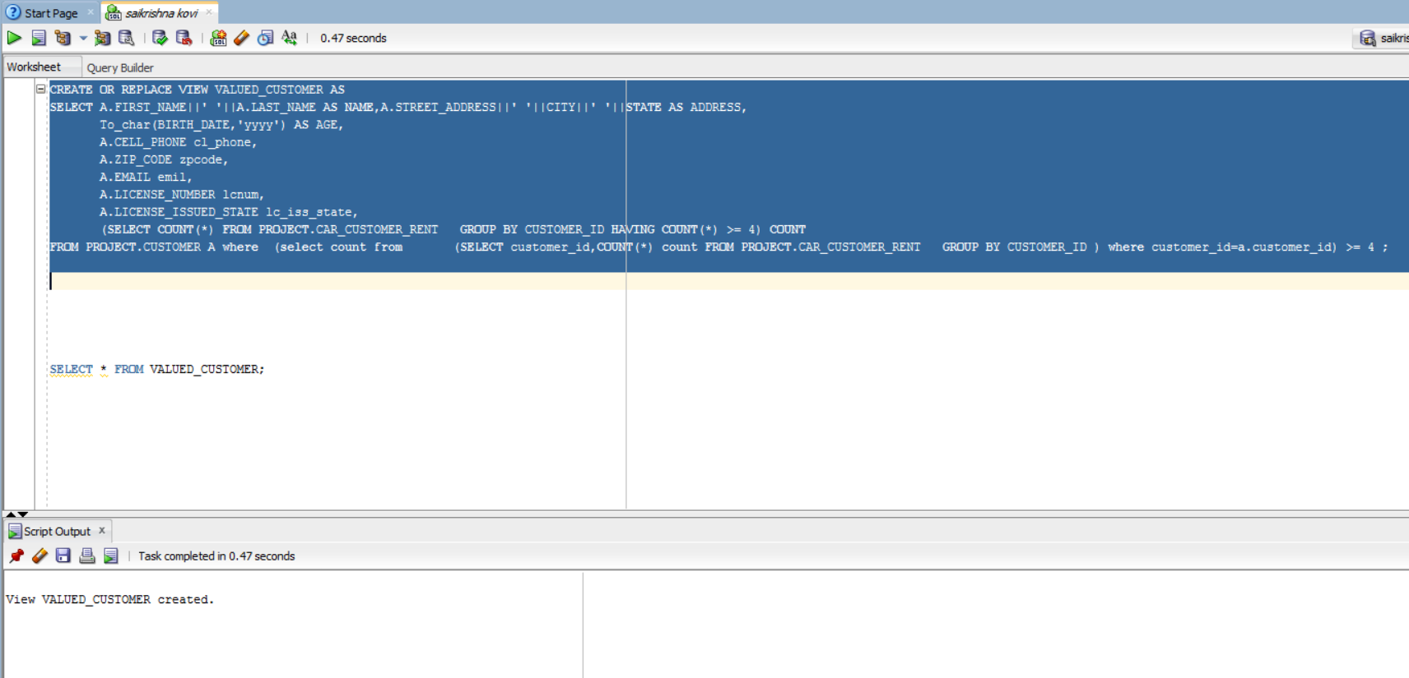

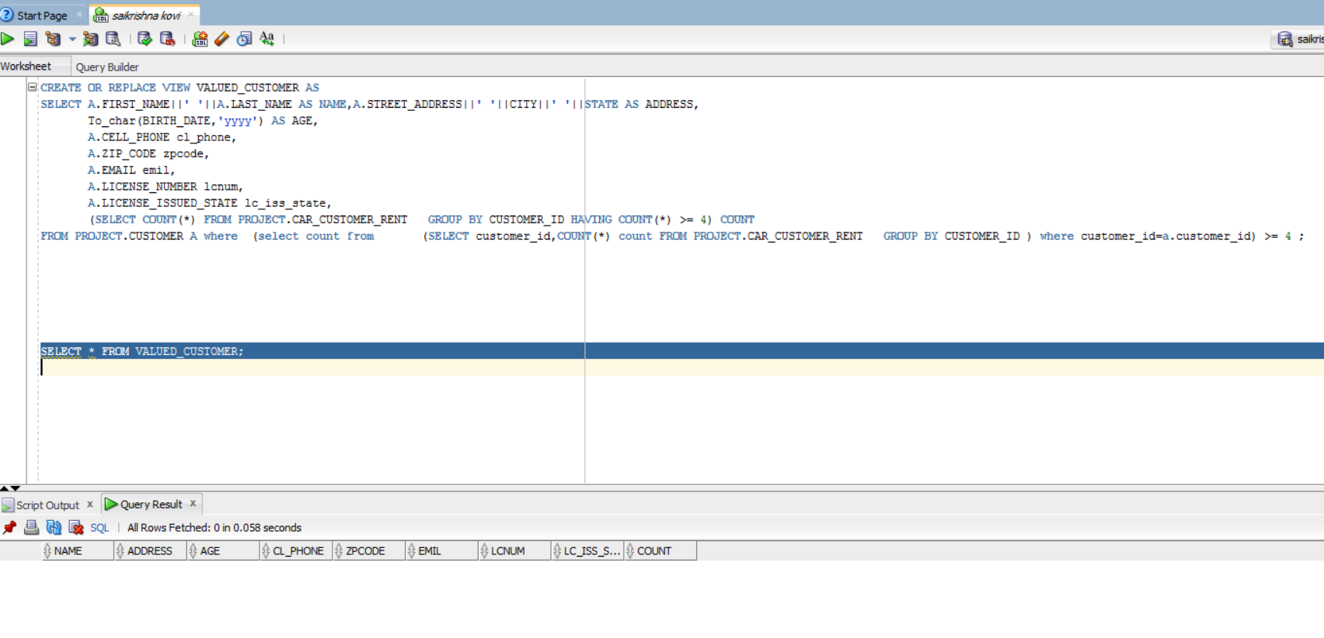

**12E.LIST_OF_CARS**

**Query:**

**create or replace vieew LIST_OF_CARS as**

**select a.CAR_ID C_ID,a.CAR_PLATE_NO CRPNO,a.CAR_STATE_REGISTERATION CAR_S_REGSTRATN,a.YEAR YEAR,b.CLIENT_ID CL_ID,a.CLASS CLS,c.DATE_OF_RENT RENTDATE,a.MAKE MAKE,a.COLOR CLR,**

**d.DAMAGE_EXTENT EXT_DAMAGE,d.COST_DAMAGE total_cost**

**FROM PROJECT.CAR a,PROJECT.CAR_CLIENT_LIST b,PROJECT.CAR_CUSTOMER_RENT c,PROJECT.ACCIDENT d**

**WHERE A.CAR_ID=b_CAR_ID AND a.CAR_ID=C.CAR_ID=c.CAR_ID AND a.CAR_ID=d.CAR_ID;**

**SELECT * FROM list_of_cars;**

**Output:**

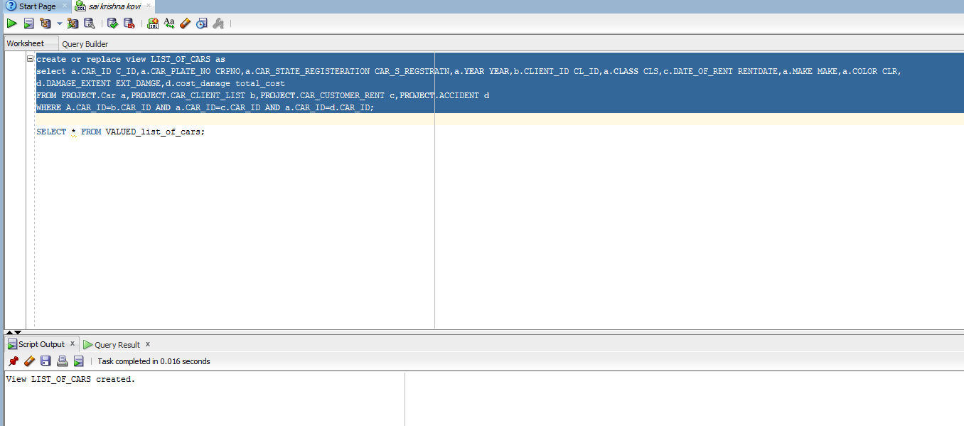

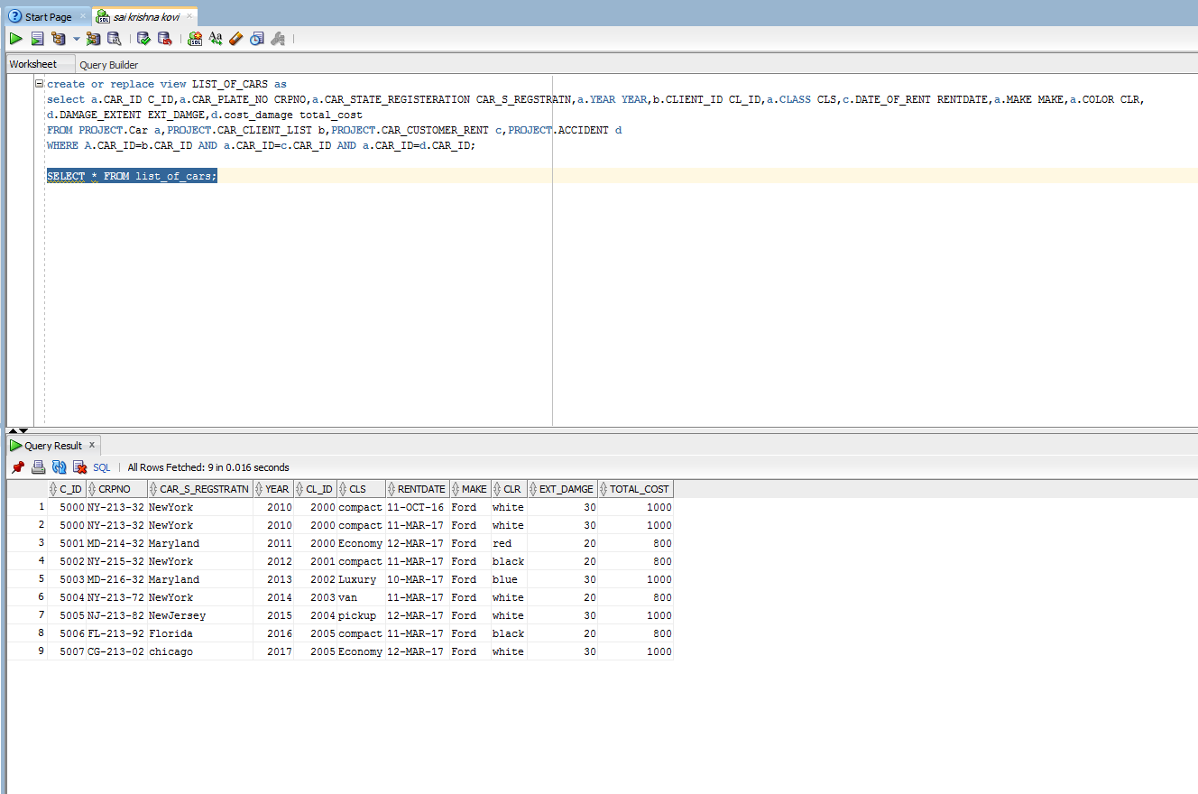

**12f.List_of_transactions**

**Query:**

**create or replace view list_of_transaction as**

**select total_costoftransaction,priceper_day,price_per_week,price_per_month,locationof_return,employeename_worked_on_car**

**from**

**(select a.client_id,b.car_id,b.payment_amount as total_cost_transaction,1*b.payment_amount as price_per_day,**

**7*b.payment_amount as price_per_week,40*b.payment_amount as price_per_month,b.location_return as location_of_return**

**from project.car_customer_rent b,project.car_client_list a where b.car_id=a.car_id) a join (select c.first_name||' '||c.last_name as employee_name_worked_on_car,d.client_id,c.employee_id**

**from project.employee c,project.employee_client_manage d where d.employee_id=c.employee_id) b on a.client_id=b.client_id;**

**select * from list_of_transaction;**

**Output:**

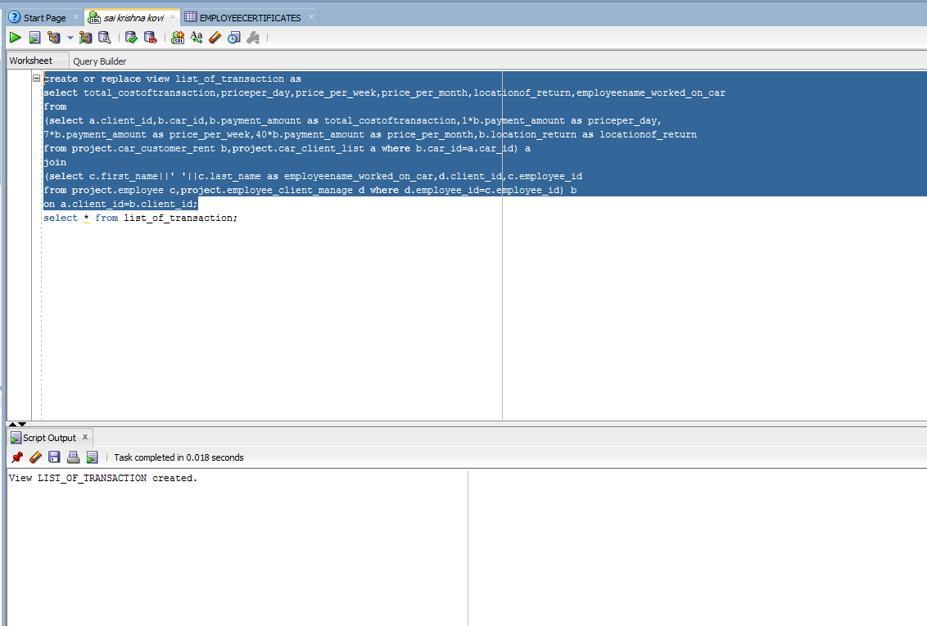

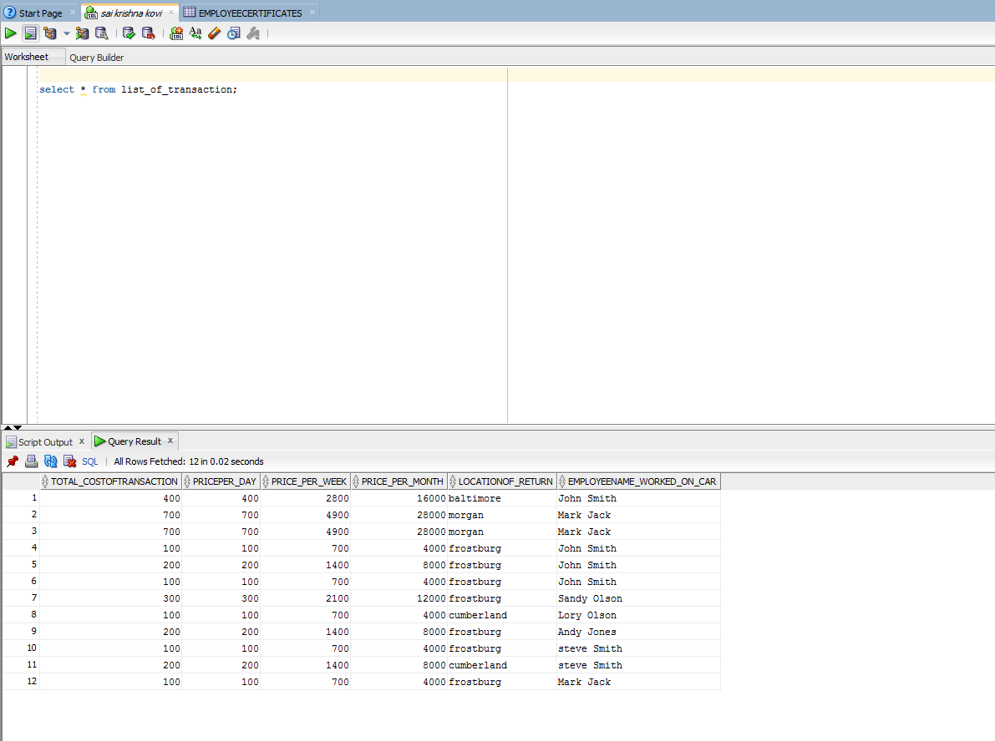

**12G.STATISTICS_BY_BRANCH YEAR**

**Query:**

**CREATE OR REPLACE VIEW Statistics_By_Branch_YEAR AS**

**SELECT a.OFFICE_id,**

**b.first_name||' '||b.middle_initial||' '||b.last_name owner_name,**

**c.first_name||' '||c.middle_initial||' '||c.last_name customer_name,**

**extract(YEAR fROM h.date_of_rent) office_year, count(c.client_id) total_num_cars, sum(h.payment_amount) total_mony_received**

**fROM office a,**

**employee_customer b,employee_client_manage ,employee d,**

**customer c,**

**client b,**

**office_employee g,**

**car_customer_rent h**

**WHeRe b.employee_id=c.employee_id**

**AND c.employee_id=d.employee_id**

**AND b.customer_id=c.customer_id**

**AND c.client_id=b.client_id**

**AND a.office_id=g.office_id**

**AND h.customer_id=c.customer_id**

**GROUP BY a.office_id,**

**b.First_name,**

**b.middle_initial,**

**b.last_name,**

**c.first_name,**

**c.middle_initial,**

**c.last_name,**

**h.date_oF_rent,**

**c.client_id,**

**h.payment_amount**

**ORDeR BY a.office_id,**

**extract(YeAR**

**fROM h.date_of_rent);**

**OUTPUT:**

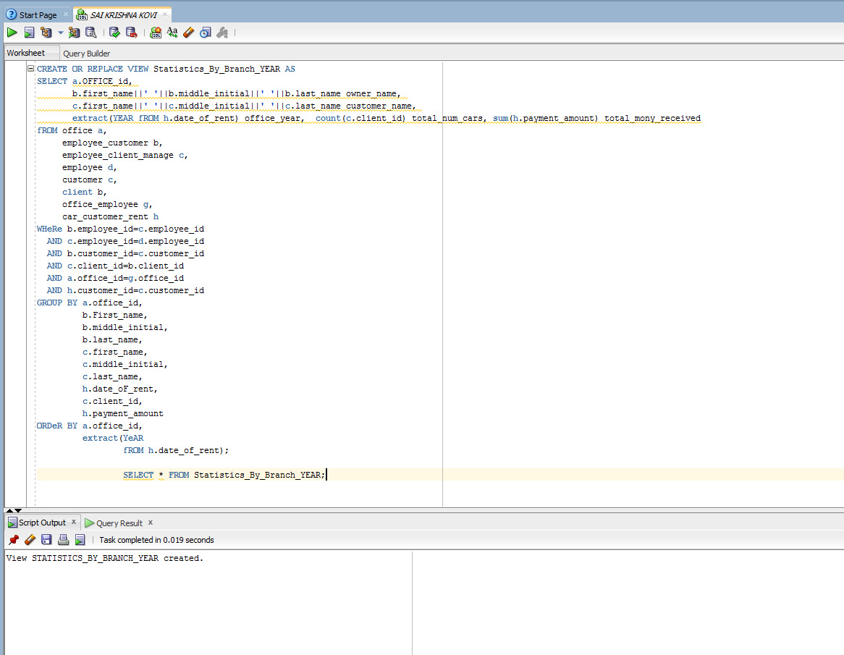

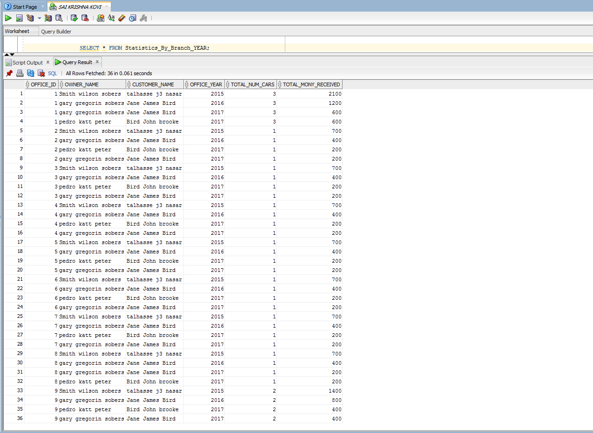

**12H.LAST_EMPLOYEE_BRANCH**

CREATE OR REPLACE VIEW LAST_EMPLOYEE_BRANCH AS

SELECT A.FIRST_NAME||' '||LAST_NAME NAME,C.NAME OFFICENAME,B.DATE_HIRED DATESTARTED,A.SALARY SALARY,TRUNC(MONTHS_BETWEEN(SYSDATE,A.BIRTH_DATE)/12)AGE

FROM PROJECT.EMPLOYEE A,PROJECT.OFFICE_EMPLOYEE B,PROJECT.OFFICE C

WHERE A.EMPLOYEE_ID=B.EMPLOYEE_ID AND B.OFFICE_ID=C.OFFICE_ID;

SELECT * FROM LAST_EMPLOYEE_BRANCH;

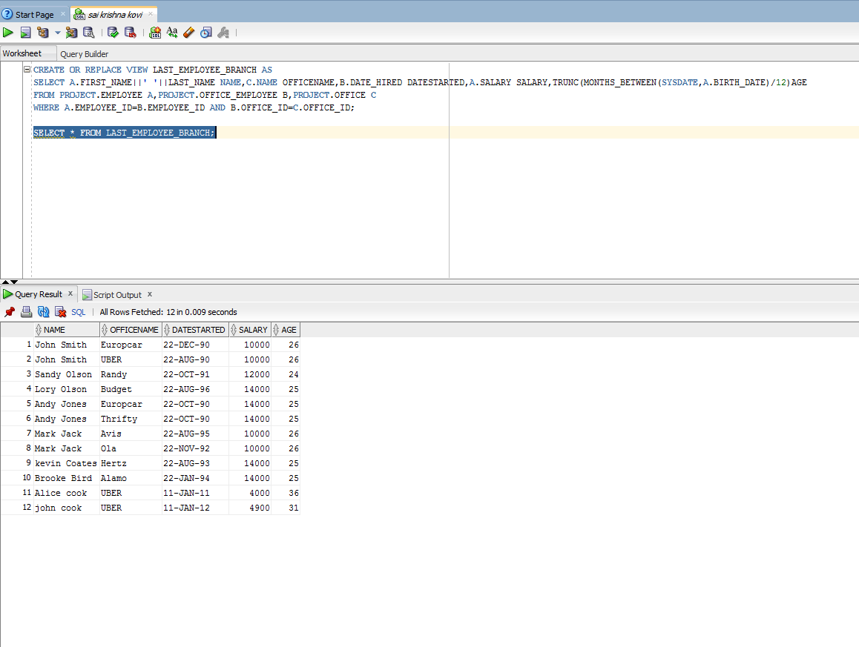

**12i. view manager**

**Query:**

**CREATE OR REPLACE FORCE VIEW MANAGERS AS**

**SELECT E.FIRST_NAME || ' ' || E.MIDDLE_NAME || ' ' || E.LAST_NAME AS MANAGER_NAME, d.DATE_HIRED,**

**(SELECT COUNT(*) FROM EMPLOYEE a, OFFICE_EMPLOYEE b WHERE b.EMPLOYEE_ID = a.EMPLOYEE_ID AND b.OFFICE_ID = d.OFFICE_ID) AS NO_OF_EMPLOYEE**

**FROM OFFICE_GENERAL_MANAGER d, EMPLOYEE E**

**WHERE E.EMPLOYEE_ID = d.GENERAL_MGR_ID**

**select * from MANAGERS;**

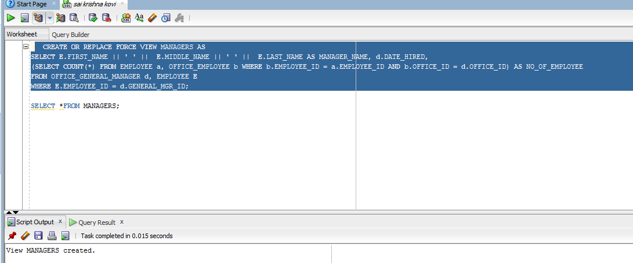

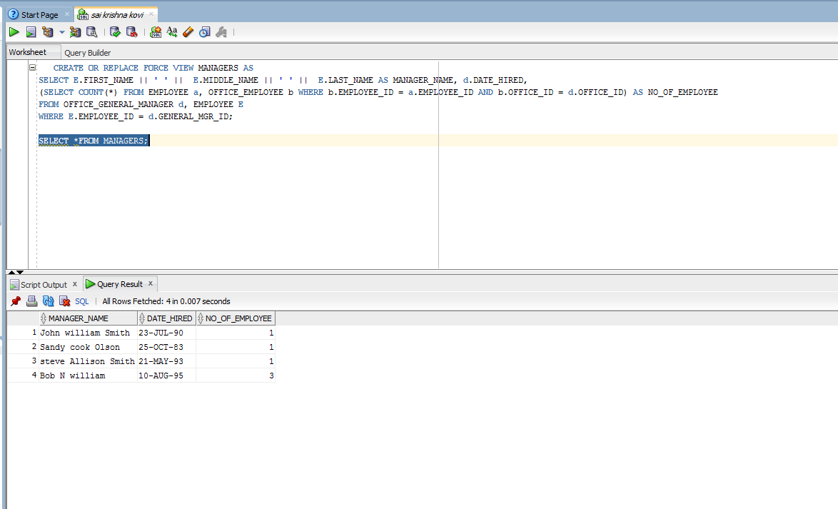

**12j.VIEW CUSTOMER_ACCIDENT**

**QUERY:**

**CREATE VIEW CUSTOMER_ACCIDENT**

**AS SELECT A.CUSTOMER_ID,A.FIRST_NAME||' '||MIDDLE_INITIAL||' '||LAST_NAME NAME,B.CAR_ID,B.LOCATION,B.COST_DAMAGE,B.DAMAGE_EXTENT**

**FROM PROJECT.CUSTOMER A,PROJECT.ACCIDENT B**

**WHERE A.CUSTOMER_ID =B.CUSTOMER_ID;**

**SELECT * FROM CUSTOMER_ACCIDENT;**

**OUTPUT:**

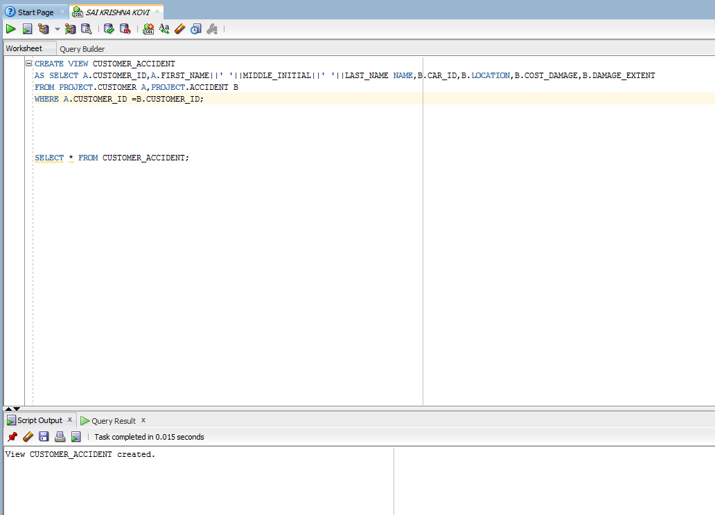

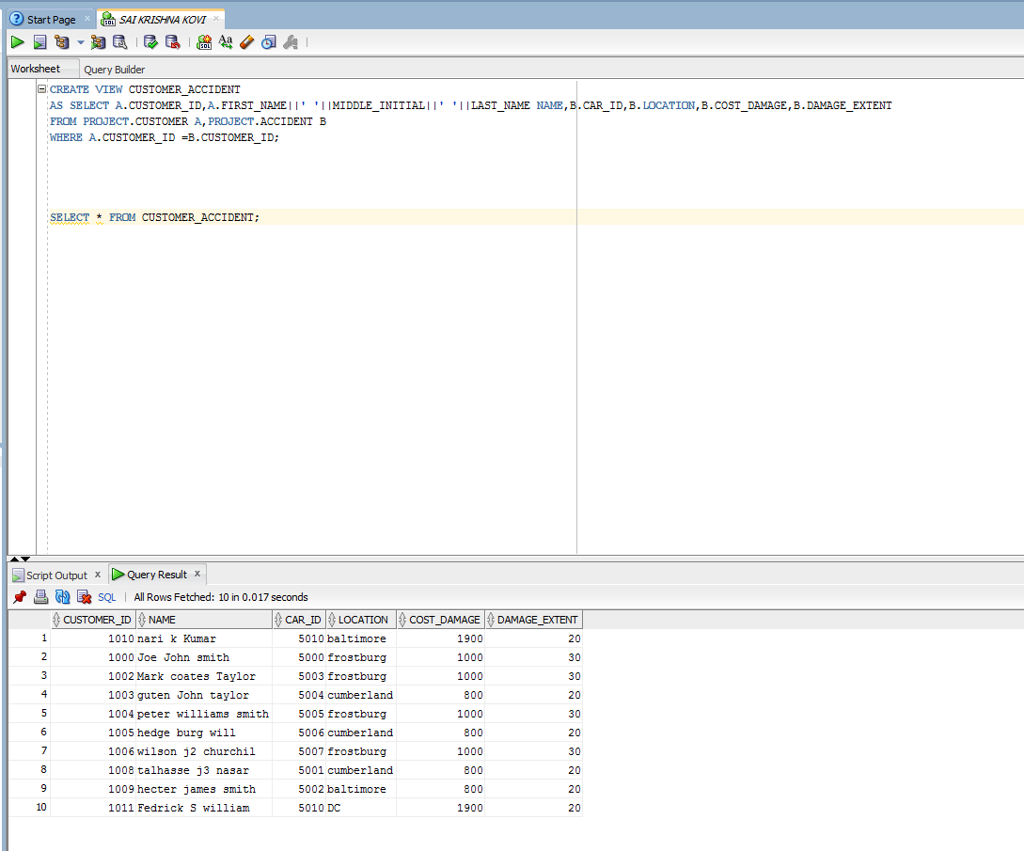

**12k. view customer_client_car**

**QUERY:**

**CREATE OR REPLACE VIEW CUSTOMER_CLIENT_CAR AS**

**SELECT A.CUSTOMER_ID CUST_ID,B.CLIENT_ID,C.CAR_ID,A.LICENSE_NUMBER,B.DATE_RETURNED,C.DATE_OF_RENT,C.LOCATION_RETURN,B.RATING FROM PROJECT.CUSTOMER A,PROJECT.CLIENT_CUSTOMER_FEEDBACK B,PROJECT.CAR_CUSTOMER_RENT C**

**WHERE A.CUSTOMER_ID=B.CUSTOMER_ID AND B.CAR_ID=C.CAR_ID;**

**SELECT * FROM CUSTOMER_CLIENT_CAR;**

**OUTPUT:**

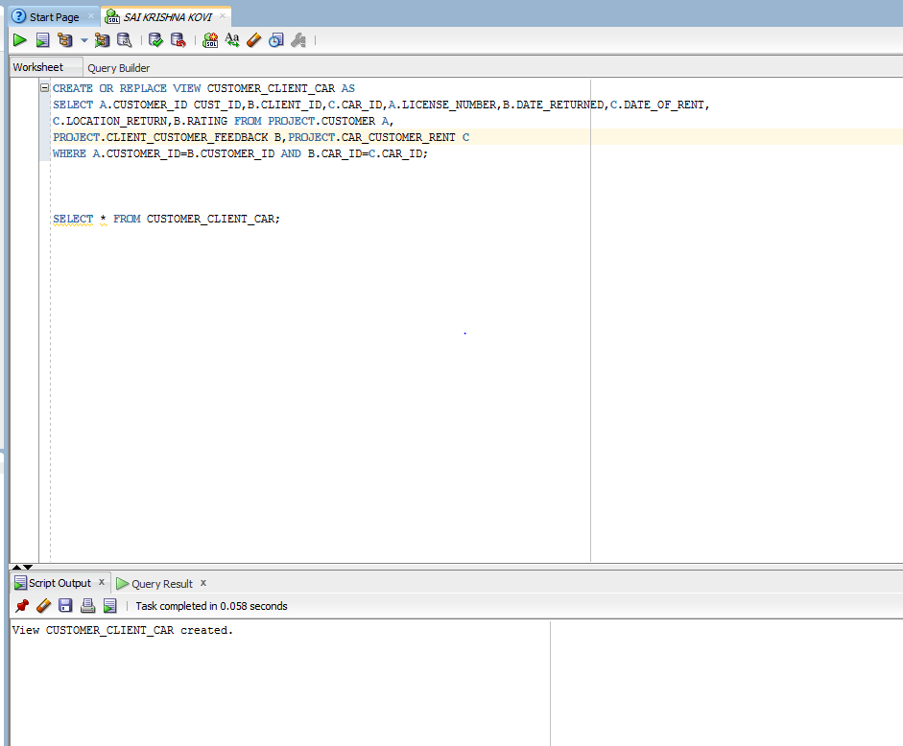

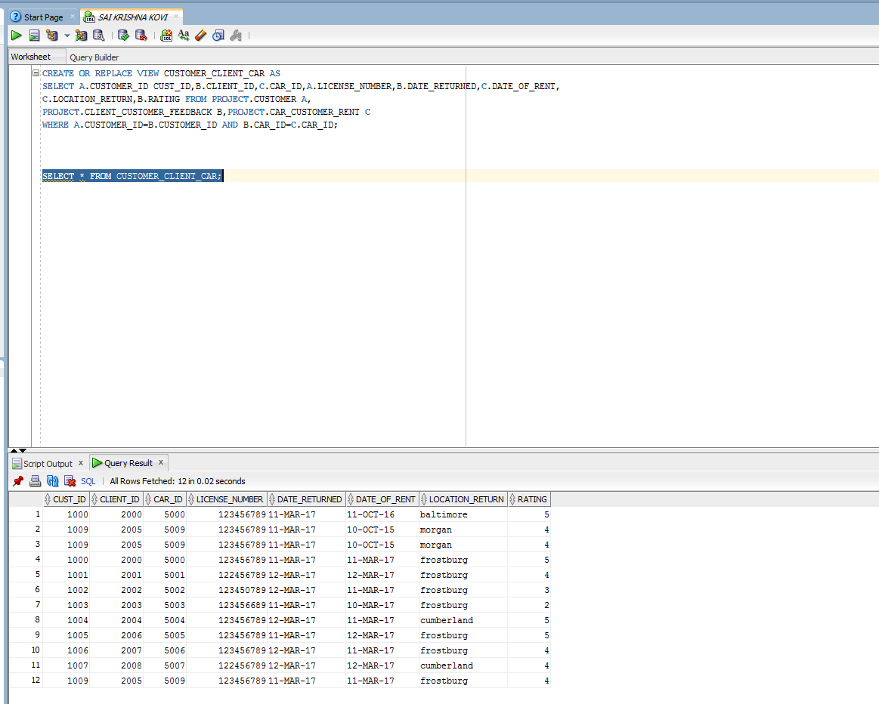

**13. INDEXES**

**13a. index on first and last name of customer**

**Query:**

**Create table customernames as select first_name,last_name from project.customer;**

**Create index customername on customernames(first_name,last_name);**

**Output:**

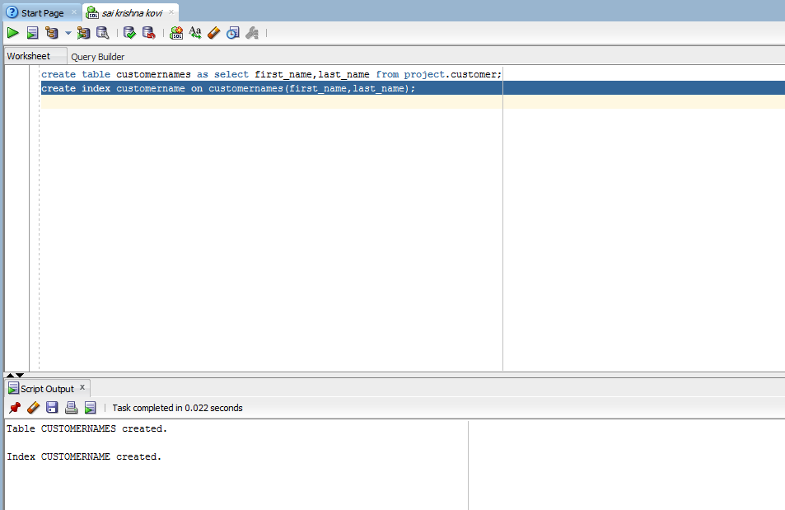

**13b.Index on birthdate of customer**

**Query:**

create table customerbirthdate as select birth_datefrom project.customer;

create index birthdate on customerbirthdate(birth_date);

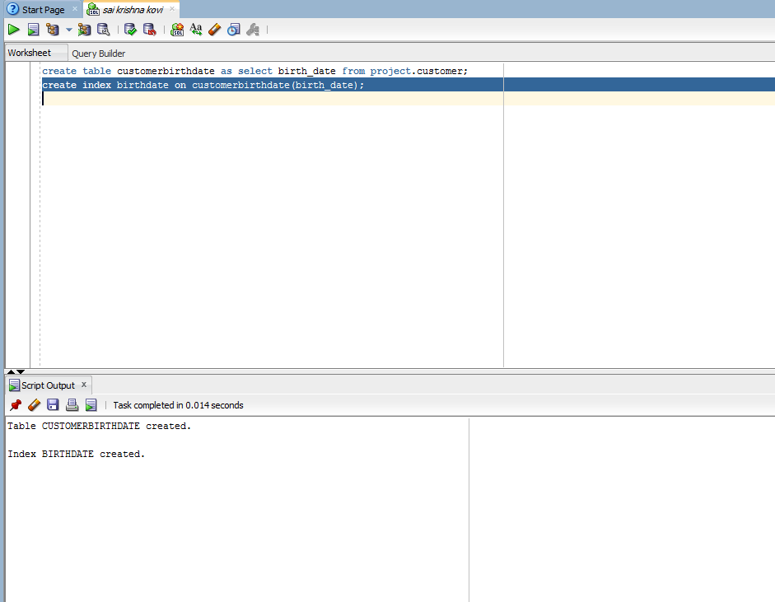

**14.SEQUENCES**

**14a. SEQUENCE ID_GENERATOR**

**Query:**

**create sequence ID_GENERATOR**

**minvalue 1**

**maxvalue 1000000**

**Start with 1000**

**Increment by 2**

**Cache 40;**

**Output:**

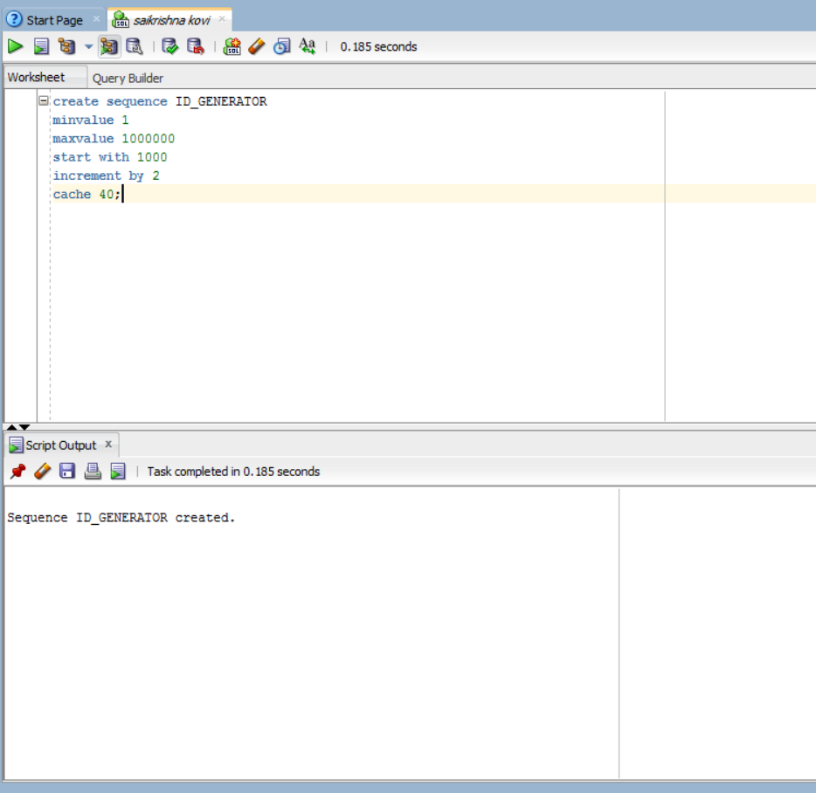

**14 b. SEQUENCE ID_TRANS_GENERATOR**

**Query:**

**Create Sequence ID_TRANS_GENERATOR**

**Minvalue 1**

**Maxvalue 99999999**

**Start with 100000**

**Increment by 1**

**Cache 30;**

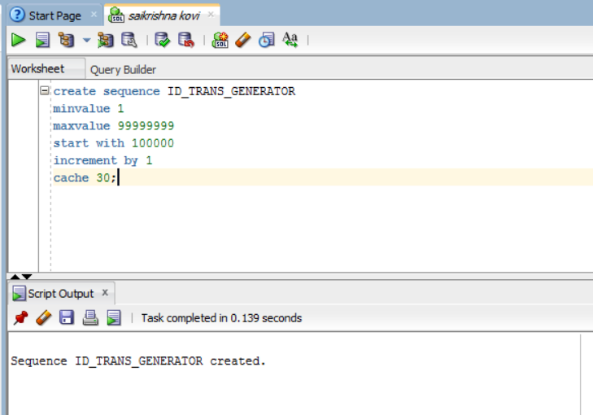

**14 c. sequence track_number**

**Query:**

**create sequence Track_Number**

**minvalue 0 maxvalue 99999999**

**start with 0**

**increment by 1**

**cache 30;**

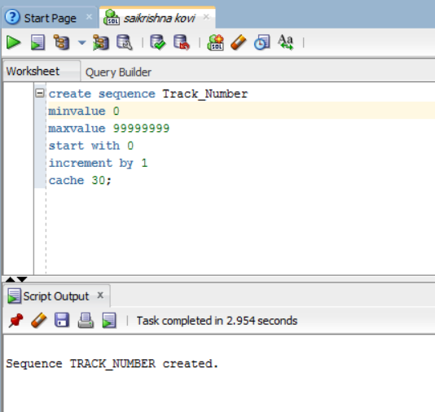

**14 d. TABLE CUSTOMER INQUIRIES**

CREATE TABLE CUSTOMER_INQUIRIES (INQUIRY_NUMBER NUMBER(10),INQUIRY_DATE DATE,TYPEOF_REQUEST VARCHAR2(40),NAME_OF_PERSON VARCHAR2(20),EMAIL_ID VARCHAR2(20));

INSERT INTO CUSTOMER_INQUIRIES VALUES (MYSEQ.NEXTVAL,TO_DATE('2017-08-14','YYYY-MM-DD'),'REQUEST FORINFORMATION','SAIKRISHNA','[SAIKOVI@GMAIL.COM](mailto:SAIKOVI@GMAIL.COM)');

INSERT INTO CUSTOMER_INQUIRIES VALUES (MYSEQ.NEXTVAL,TO_DATE('2017-06-10','YYYY-MM-DD'),'REQUEST','KAJJIKAYA','[KAJJIKAYA@GMAIL.COM](mailto:KAJJIKAYA@GMAIL.COM)');

INSERT INTO CUSTOMER_INQUIRIES VALUES (MYSEQ.NEXTVAL,TO_DATE('2017-07-14','YYYY-MM-DD'),'CAR AVAILABILITYREPORT','DAMODAR REDDY','[DMREDDY@GMAIL.COM](mailto:DMREDDY@GMAIL.COM)');

INSERT INTO CUSTOMER_INQUIRIES VALUES (MYSEQ.NEXTVAL,TO_DATE('2017-06-17','YYYY-MM-DD'),'CAR INFO','GEORGE B RINARD','[GEORGE@GMAIL.COM](mailto:JHON@GMAIL.COM)');

INSERT INTO CUSTOMER_INQUIRIES VALUES (MYSEQ.NEXTVAL,TO_DATE('2017-04-13','YYYY-MM-DD'),'DATA','SIVASAI','[SIVASAI@GMAIL.COM](mailto:RAM@GMAIL.COM)');

SELECT * FROM CUSTOMER_INQUIRIES

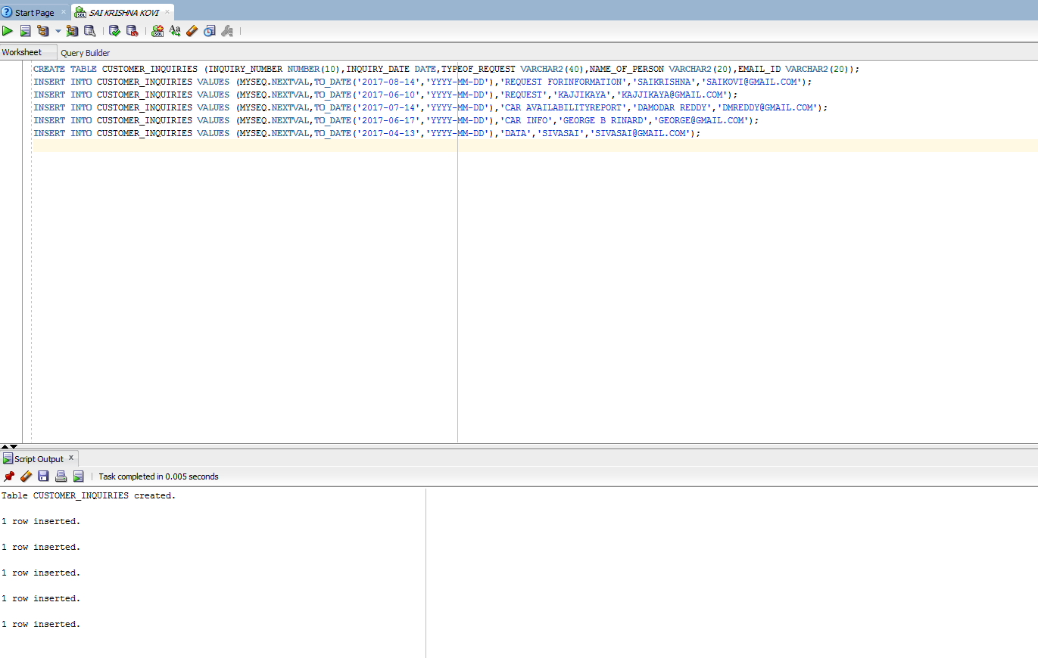

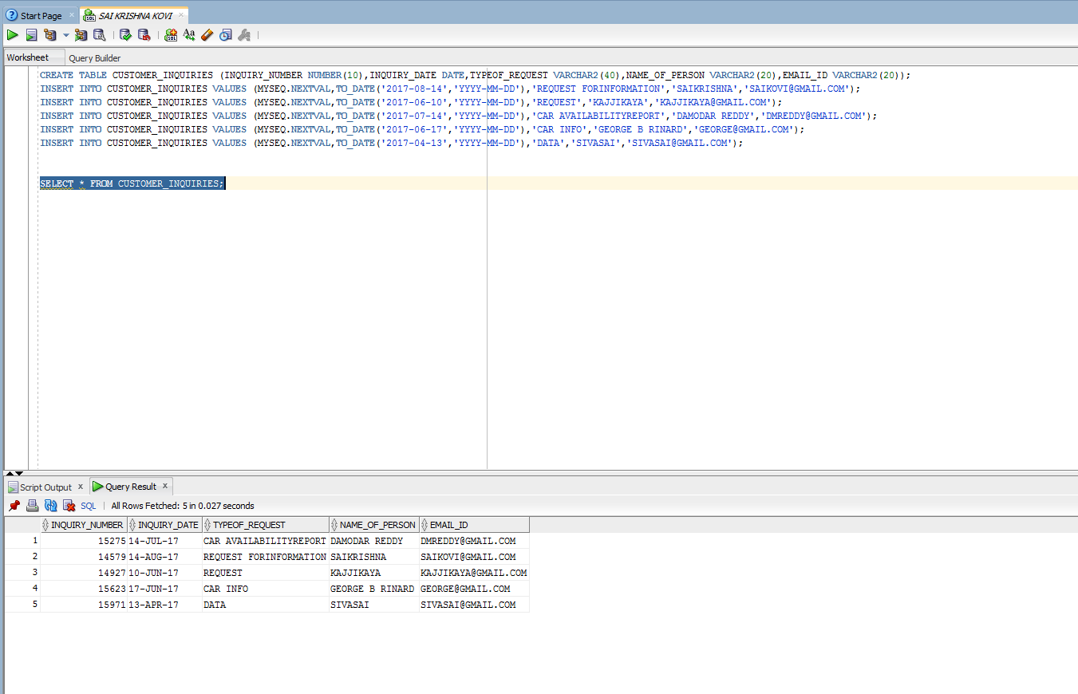

**SUB PROGRAMMS**

**15A. PACKAGE EMPINSERT_PKG**

**QUERY:**

**CREATE OR REPLACE PACKAGE EMPINSERT_PKG AS**

**PROCEDURE INSERT_DATA**

**(s_EMP_ID EMPLOYEE.EMPLOYEE_ID%TYPE,**

**s_FNAME EMPLOYEE.FIRST_NAME%TYPE,**

**s_MNAME EMPLOYEE.MIDDLE_NAME%TYPE,**

**s_LNAME EMPLOYEE.LAST_NAME%TYPE,**

**s_GENDER EMPLOYEE.GENDER%TYPE,**

**s_STREETADDRESS EMPLOYEE.STREET_ADDRESS%TYPE,**

**s_CITY EMPLOYEE.CITY%TYPE,**

**s_STATE EMPLOYEE.STATE%TYPE,**

**s_ZIPCODE EMPLOYEE.ZIP_CODE%TYPE,**

**s_SSN EMPLOYEE.SSN%TYPE,**

**s_SALARY EMPLOYEE.SALARY%TYPE,**

**s_TAX_DEDUCTION EMPLOYEE.TAX_DEDUCTION%TYPE,**

**s_BIRTH_DATE EMPLOYEE.BIRTH_DATE%TYPE,**

**s_MARITAL_STATUS EMPLOYEE.MARITAL_STATUS%TYPE,**

**s_SPOUSE_NAME EMPLOYEE.SPOUSE_NAME%TYPE,**

**s_LAST_DEGREE EMPLOYEE.LAST_DEGREE%TYPE,**

**s_DATE_DEGREE EMPLOYEE.DATE_DEGREE%TYPE,**

**s_NO_OF_DEPENDENTS EMPLOYEE.NO_OF_DEPENDENTS%TYPE,**

**s_HOME_PHONE_NUMBER EMPLOYEE.HOME_PHONE_NUMBER%TYPE,**

**s_CELL_PHONE_NUMBER EMPLOYEE.CELL_PHONE_NUMBER%TYPE);**

**PROCEDURE MARITAL_STATUS_UPDATE(B_EMP IN EMPLOYEE.EMPLOYEE_ID%TYPE,B_MARITAL_STATUS EMPLOYEE.MARITAL_STATUS%TYPE);**

**PROCEDURE LAST_DEGREE_UPDATE(B_EMP EMPLOYEE.EMPLOYEE_ID%TYPE,B_LAST_DEGREE EMPLOYEE.LAST_DEGREE%TYPE);**

**PROCEDURE CERTIFICATE_UPDATE(B_EMP EMPLOYEE_CERTIFICATES.EMPLOYEE_ID%TYPE,B_CERTIFICATE EMPLOYEE_CERTIFICATES.LIST_OF_CERTIFICATES%TYPE);**

**PROCEDURE MANAGER_UPDATE(MANAGER_ID OFFICE_GENERAL_MANAGER.GENERAL_MGR_ID%TYPE,B_EMP EMPLOYEE.EMPLOYEE_ID%TYPE);**

**END EMPINSERT_PKG;**

**/**

**SET SERVEROUTPUT ON;**

**CREATE OR REPLACE PACKAGE BODY EMPINSERT_PKG AS**

**PROCEDURE INSERT_DATA**

**(s_EMP_ID EMPLOYEE.EMPLOYEE_ID%TYPE,**

**s_FNAME EMPLOYEE.FIRST_NAME%TYPE,**

**s_MNAME EMPLOYEE.MIDDLE_NAME%TYPE,**

**s_LNAME EMPLOYEE.LAST_NAME%TYPE,**

**s_GENDER EMPLOYEE.GENDER%TYPE,**

**s_STREETADDRESS EMPLOYEE.STREET_ADDRESS%TYPE,**

**s_CITY EMPLOYEE.CITY%TYPE,**

**s_STATE EMPLOYEE.STATE%TYPE,**

**s_ZIPCODE EMPLOYEE.ZIP_CODE%TYPE,**

**s_SSN EMPLOYEE.SSN%TYPE,**

**s_SALARY EMPLOYEE.SALARY%TYPE,**

**s_TAX_DEDUCTION EMPLOYEE.TAX_DEDUCTION%TYPE,**

**s_BIRTH_DATE EMPLOYEE.BIRTH_DATE%TYPE,**

**s_MARITAL_STATUS EMPLOYEE.MARITAL_STATUS%TYPE,**

**s_SPOUSE_NAME EMPLOYEE.SPOUSE_NAME%TYPE,**

**s_LAST_DEGREE EMPLOYEE.LAST_DEGREE%TYPE,**

**s_DATE_DEGREE EMPLOYEE.DATE_DEGREE%TYPE,**

**s_NO_OF_DEPENDENTS EMPLOYEE.NO_OF_DEPENDENTS%TYPE,**

**s_HOME_PHONE_NUMBER EMPLOYEE.HOME_PHONE_NUMBER%TYPE,**

**s_CELL_PHONE_NUMBER EMPLOYEE.CELL_PHONE_NUMBER%TYPE)AS**

**BEGIN**

**INSERT INTO EMPLOYEE (EMPLOYEE_ID,FIRST_NAME,MIDDLE_NAME,LAST_NAME,GENDER,STREET_ADDRESS,CITY,STATE,ZIP_CODE,SSN,SALARY,TAX_DEDUCTION,BIRTH_DATE,MARITAL_STATUS,**

**SPOUSE_NAME,LAST_DEGREE,DATE_DEGREE,NO_OF_DEPENDENTS,HOME_PHONE_NUMBER,CELL_PHONE_NUMBER)**

**VALUES(s_EMP_ID,s_FNAME,s_MNAME,s_LNAME,s_GENDER,s_STREETADDRESS,s_CITY,s_STATE,s_ZIPCODE,s_SSN,s_SALARY,s_TAX_DEDUCTION,s_BIRTH_DATE,S_MARITAL_STATUS,**

**s_SPOUSE_NAME,s_LAST_DEGREE,s_DATE_DEGREE,s_NO_OF_DEPENDENTS,s_HOME_PHONE_NUMBER,s_CELL_PHONE_NUMBER);**

**DBMS_OUTPUT.PUT_LINE('EMPLOYEE TABLE UPDATED');**

**END;**

**PROCEDURE MARITAL_STATUS_UPDATE(B_EMP IN EMPLOYEE.EMPLOYEE_ID%TYPE,B_MARITAL_STATUS EMPLOYEE.MARITAL_STATUS%TYPE) AS**

**BEGIN**

**UPDATE EMPLOYEE SET MARITAL_STATUS = B_MARITAL_STATUS WHERE EMPLOYEE_ID=B_EMP;**

**DBMS_OUTPUT.PUT_LINE('MARITAL STATUS UPDATED');**

**END;**

**PROCEDURE LAST_DEGREE_UPDATE(B_EMP EMPLOYEE.EMPLOYEE_ID%TYPE,B_LAST_DEGREE EMPLOYEE.LAST_DEGREE%TYPE) AS**

**BEGIN**

**UPDATE EMPLOYEE SET LAST_DEGREE = B_LAST_DEGREE WHERE EMPLOYEE_ID=B_EMP;**

**DBMS_OUTPUT.PUT_LINE('LAST DEGREE UPDATED');**

**END;**

**PROCEDURE CERTIFICATE_UPDATE(B_EMP EMPLOYEE_CERTIFICATES.EMPLOYEE_ID%TYPE,B_CERTIFICATE EMPLOYEE_CERTIFICATES.LIST_OF_CERTIFICATES%TYPE) AS**

**BEGIN**

**UPDATE EMPLOYEE_CERTIFICATES SET LIST_OF_CERTIFICATES = B_CERTIFICATE WHERE EMPLOYEE_ID=B_EMP;**

**DBMS_OUTPUT.PUT_LINE('EMPLOYEE CERTIFICATE UPDATED');**

**END;**

**PROCEDURE MANAGER_UPDATE(MANAGER_ID OFFICE_GENERAL_MANAGER.GENERAL_MGR_ID%TYPE,B_EMP EMPLOYEE.EMPLOYEE_ID%TYPE) AS**

**BEGIN**

**UPDATE OFFICE_GENERAL_MANAGER SET GENERAL_MGR_ID = B_EMP WHERE GENERAL_MGR_ID = MANAGER_ID;**

**DBMS_OUTPUT.PUT_LINE('EMPLOYEE MANAGER UPDATED');**

**EXCEPTION**

**WHEN NO_DATA_FOUND THEN**

**DBMS_OUTPUT.PUT_LINE('NO DATA FOUND');**

**WHEN TOO_MANY_ROWS THEN**

**DBMS_OUTPUT.PUT_LINE('TOO MANY ROWS');**

**WHEN OTHERS THEN**

**DBMS_OUTPUT.PUT_LINE('ERROR');**

**END;**

**END EMPINSERT_PKG;**

**Output:**

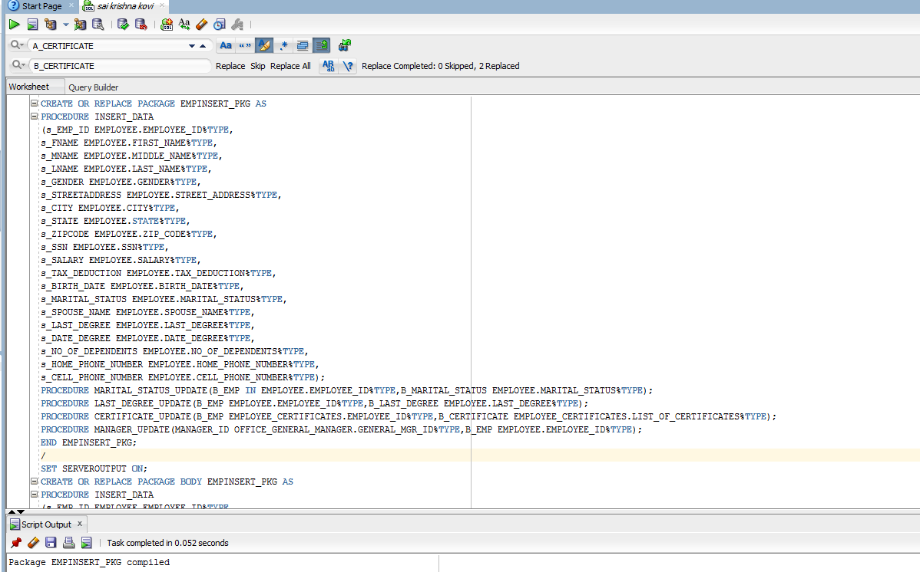

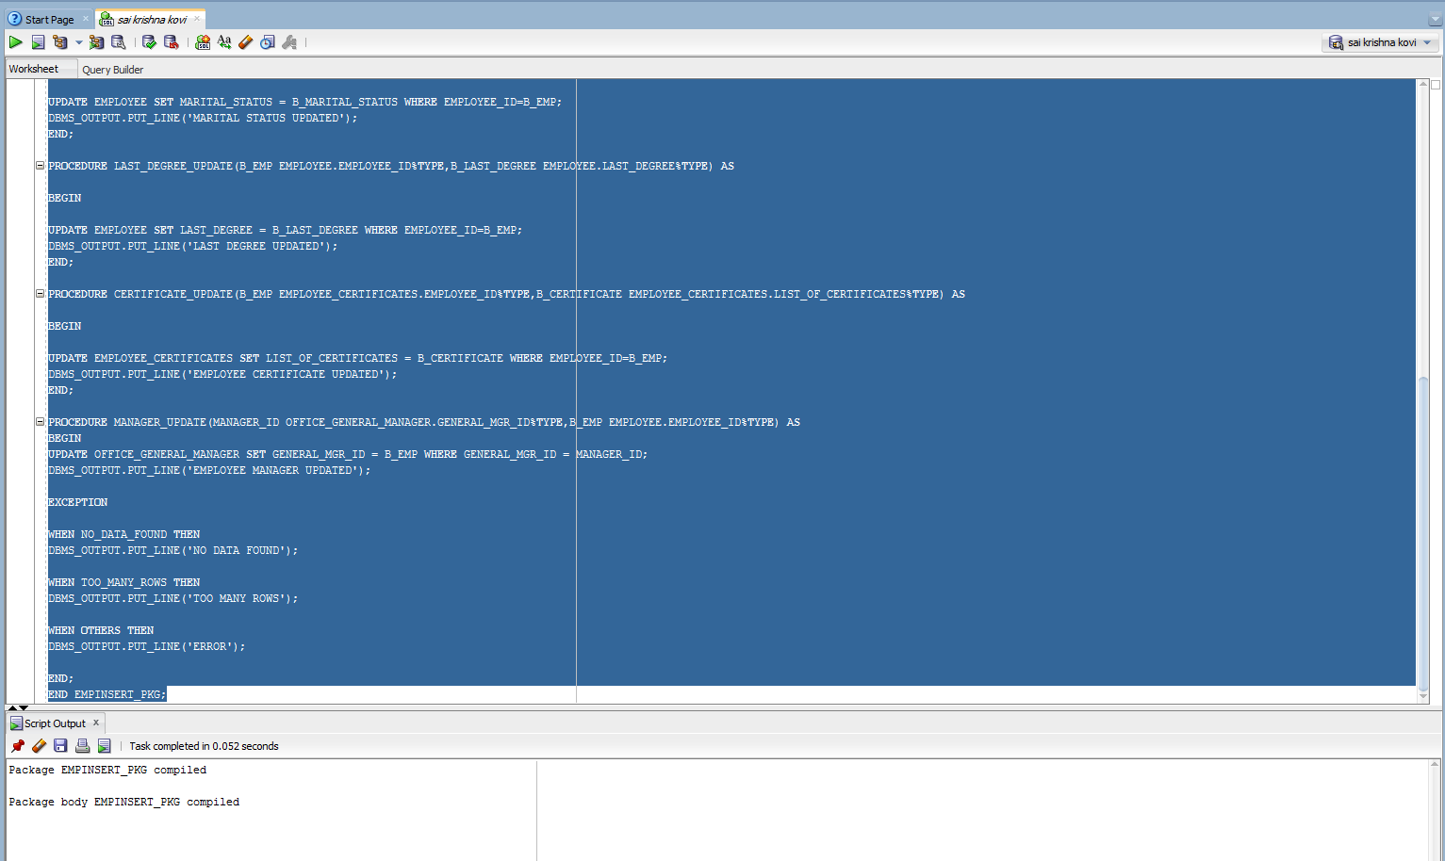

**15b. insert_pkg**

**Query:**

**CREATE OR REPLACE PACKAGE INSERT_PKG AS**

**PROCEDURE INSERT_DATA_1**

**(CUSTOMERID CUSTOMER.CUSTOMER_ID%TYPE,**

**F_NAME CUSTOMER.FIRST_NAME%TYPE,**

**M_NAME CUSTOMER.MIDDLE_INITIAL%TYPE,**

**L_NAME CUSTOMER.LAST_NAME%TYPE,**

**ST_ADDRESS CUSTOMER.STREET_ADDRESS%TYPE,**

**CITY CUSTOMER.CITY%TYPE,**

**STATE CUSTOMER.STATE%TYPE,**

**ZIP CUSTOMER.ZIP_CODE%TYPE,**

**B_DATE CUSTOMER.BIRTH_DATE%TYPE,**

**EMAIL CUSTOMER.EMAIL%TYPE,**

**LICENSEISS_STATE CUSTOMER.LICENSE_ISSUED_STATE%TYPE,**

**LICENSE_NUM CUSTOMER.LICENSE_NUMBER%TYPE,**

**CREDIT_CARD_NUM CUSTOMER.CREDIT_CARD_NUMBER%TYPE,**

**EXPIRATION_DT CUSTOMER.EXPIRATION_DATE%TYPE,**

**CELL_PHONENO CUSTOMER.CELL_PHONE%TYPE);**

**PROCEDURE INSERT_NEW_CAR_OWNER(CAR_ID CAR_CLIENT_LIST.CAR_ID%TYPE,CLIENT_ID CAR_CLIENT_LIST.CLIENT_ID%TYPE,**

**AVAILABLE_HRS CAR_CLIENT_LIST.AVAILABLE_HRS%TYPE,START_DATE CAR_CLIENT_LIST.START_DATE%TYPE,**

**END_DATE CAR_CLIENT_LIST.END_DATE%TYPE);**

**PROCEDURE INFO_UPDATE_CUSTOMER(CUST_ID CUSTOMER.CUSTOMER_ID%TYPE,STREET CUSTOMER.STREET_ADDRESS%TYPE);**

**PROCEDURE INFO_UPDATE_CAROWNER(EXISTING_CAR_ID CAR_CLIENT_LIST.CAR_ID%TYPE,NEW_CLIENT_ID CAR_CLIENT_LIST.CLIENT_ID%TYPE);**

**PROCEDURE INSERT_ACCIDENT(CUSTOMER_ID ACCIDENT.CUSTOMER_ID%TYPE,CAR_ID ACCIDENT.CAR_ID%TYPE,DATE_TIME ACCIDENT.DATE_TIME%TYPE,**

**LOCATION_1 ACCIDENT.LOCATION%TYPE,DAMAGE_EXTENT ACCIDENT.DAMAGE_EXTENT%TYPE,COST_DAMAGE ACCIDENT.COST_DAMAGE%TYPE,**

**POLICE_REPORT ACCIDENT.POLICE_REPORT%TYPE,SUMMARY_1 ACCIDENT.SUMMARY_POLICE_REPORT%TYPE);**

**END INSERT_PKG;**

**/**

**SET SERVEROUTPUT ON;**

**CREATE OR REPLACE PACKAGE BODY INSERT_PKG AS**

**PROCEDURE INSERT_DATA_1**

**(CUSTOMERID CUSTOMER.CUSTOMER_ID%TYPE,**

**F_NAME CUSTOMER.FIRST_NAME%TYPE,**

**M_NAME CUSTOMER.MIDDLE_INITIAL%TYPE,**

**L_NAME CUSTOMER.LAST_NAME%TYPE,**

**ST_ADDRESS CUSTOMER.STREET_ADDRESS%TYPE,**

**CITY CUSTOMER.CITY%TYPE,**

**STATE CUSTOMER.STATE%TYPE,**

**ZIP CUSTOMER.ZIP_CODE%TYPE,**

**B_DATE CUSTOMER.BIRTH_DATE%TYPE,**

**EMAIL CUSTOMER.EMAIL%TYPE,**

**LICENSEISS_STATE CUSTOMER.LICENSE_ISSUED_STATE%TYPE,**

**LICENSE_NUM CUSTOMER.LICENSE_NUMBER%TYPE,**

**CREDIT_CARD_NUM CUSTOMER.CREDIT_CARD_NUMBER%TYPE,**

**EXPIRATION_DT CUSTOMER.EXPIRATION_DATE%TYPE,**

**CELL_PHONENO CUSTOMER.CELL_PHONE%TYPE) AS**

**BEGIN**

**INSERT INTO CUSTOMER (CUSTOMER_ID,FIRST_NAME,MIDDLE_INITIAL,LAST_NAME,STREET_ADDRESS,CITY,STATE,ZIP_CODE,BIRTH_DATE,EMAIL,LICENSE_ISSUED_STATE,LICENSE_NUMBER,CREDIT_CARD_NUMBER,EXPIRATION_DATE,CELL_PHONE)**

**VALUES(CUSTOMERID,F_NAME,M_NAME,L_NAME,ST_ADDRESS,CITY,STATE,ZIP,B_DATE,EMAIL,LICENSEISS_STATE,LICENSE_NUM,CREDIT_CARD_NUM,EXPIRATION_DT,CELL_PHONENO);**

**DBMS_OUTPUT.PUT_LINE('CUSTOMER TABLE UPDATED');**

**END;**

**PROCEDURE INSERT_NEW_CAR_OWNER(CAR_ID CAR_CLIENT_LIST.CAR_ID%TYPE,CLIENT_ID CAR_CLIENT_LIST.CLIENT_ID%TYPE,**

**AVAILABLE_HRS CAR_CLIENT_LIST.AVAILABLE_HRS%TYPE,START_DATE CAR_CLIENT_LIST.START_DATE%TYPE,**

**END_DATE CAR_CLIENT_LIST.END_DATE%TYPE) AS**

**BEGIN**

**INSERT INTO CAR_CLIENT_LIST(CAR_ID,CLIENT_ID,AVAILABLE_HRS,START_DATE,END_DATE)**

**VALUES(CAR_ID,CLIENT_ID,AVAILABLE_HRS,START_DATE,END_DATE);**

**DBMS_OUTPUT.PUT_LINE('NEW CAR OWNER INFORMATIONUPDATED');**

**END;**

**PROCEDURE INFO_UPDATE_CUSTOMER(CUST_ID CUSTOMER.CUSTOMER_ID%TYPE,STREET CUSTOMER.STREET_ADDRESS%TYPE) AS**

**BEGIN**

**UPDATE CUSTOMER SET STREET_ADDRESS = STREET WHERE CUSTOMER_ID = CUST_ID;**

**DBMS_OUTPUT.PUT_LINE('CUSTOMER INFORMATION UPDATED');**

**END;**

**PROCEDURE INFO_UPDATE_CAROWNER(EXISTING_CAR_ID CAR_CLIENT_LIST.CAR_ID%TYPE,NEW_CLIENT_ID CAR_CLIENT_LIST.CLIENT_ID%TYPE) AS**

**BEGIN**

**UPDATE CAR_CLIENT_LIST SET CLIENT_ID = NEW_CLIENT_ID WHERE CAR_ID = EXISTING_CAR_ID;**

**DBMS_OUTPUT.PUT_LINE('CAROWNER INFORMATION UPDATED');**

**END;**

**PROCEDURE INSERT_ACCIDENT(CUSTOMER_ID ACCIDENT.CUSTOMER_ID%TYPE,CAR_ID ACCIDENT.CAR_ID%TYPE,DATE_TIME ACCIDENT.DATE_TIME%TYPE,**

**LOCATION_1 ACCIDENT.LOCATION%TYPE,DAMAGE_EXTENT ACCIDENT.DAMAGE_EXTENT%TYPE,COST_DAMAGE ACCIDENT.COST_DAMAGE%TYPE,**

**POLICE_REPORT ACCIDENT.POLICE_REPORT%TYPE,SUMMARY_1 ACCIDENT.SUMMARY_POLICE_REPORT%TYPE) AS**

**BEGIN**

**INSERT INTO ACCIDENT(CUSTOMER_ID,CAR_ID,DATE_TIME,LOCATION,DAMAGE_EXTENT,COST_DAMAGE,POLICE_REPORT,SUMMARY_POLICE_REPORT)**

**VALUES (CUSTOMER_ID,CAR_ID,DATE_TIME,LOCATION_1,DAMAGE_EXTENT,COST_DAMAGE,POLICE_REPORT,SUMMARY_1);**

**DBMS_OUTPUT.PUT_LINE('NEW ACCIDENT RECORD HAS BEEN UPDATED');**

**EXCEPTION**

**WHEN NO_DATA_FOUND THEN**

**DBMS_OUTPUT.PUT_LINE('NO DATA IS FOUND');**

**WHEN TOO_MANY_ROWS THEN**

**DBMS_OUTPUT.PUT_LINE('TOO MANY ROWS');**

**WHEN OTHERS THEN**

**DBMS_OUTPUT.PUT_LINE('UNKNOWN ERROR HAS OCCURRED');**

**END;**

**END INSERT_PKG;**

**Output:**

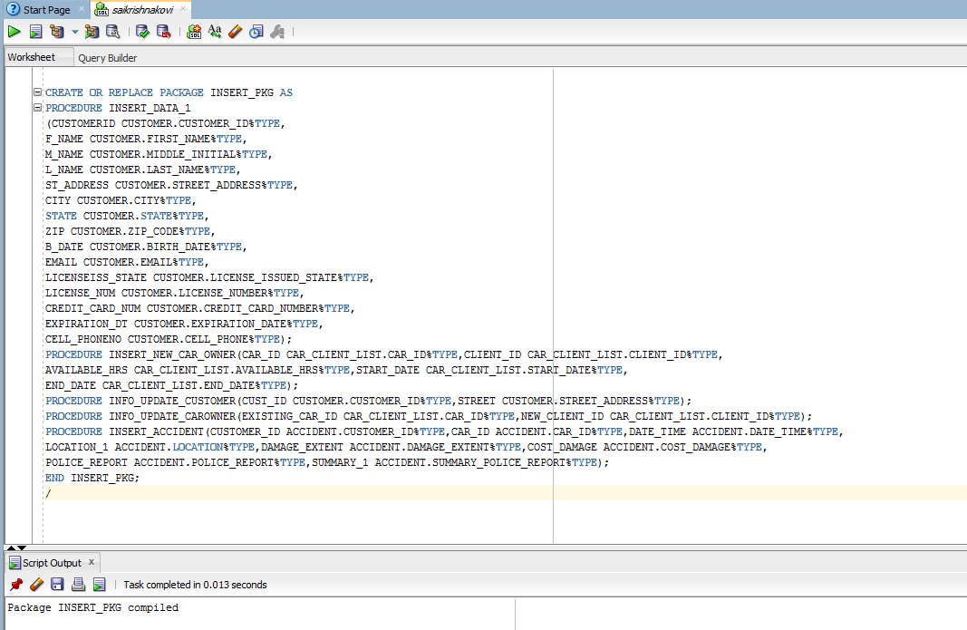

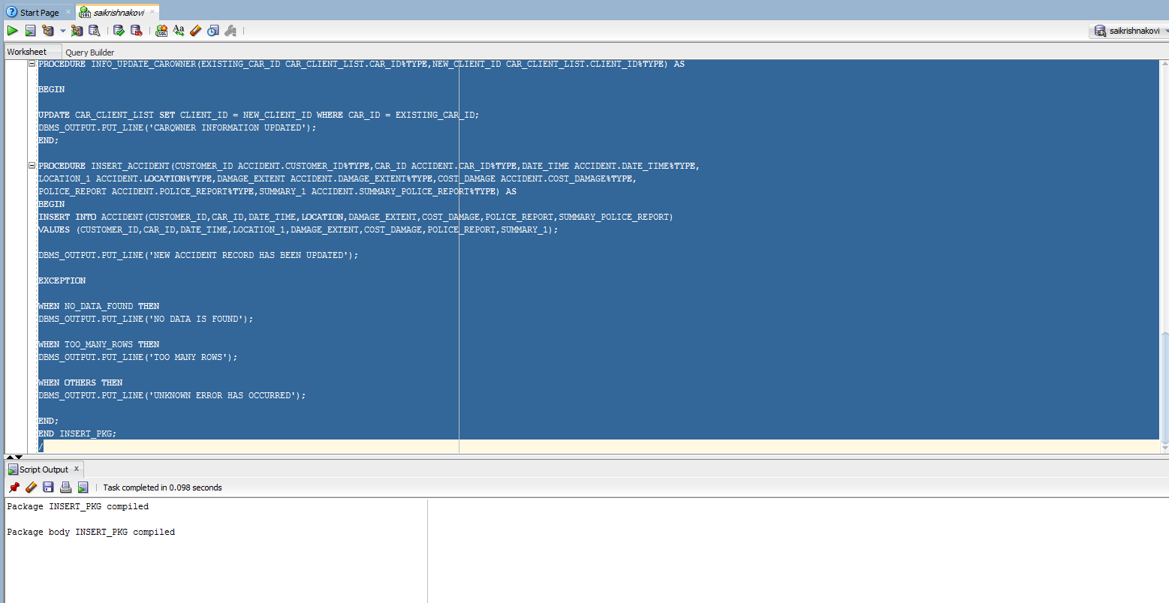

**15C. VEHICLE_PKG**

**QUERY:**

**CREATE OR REPLACE PACKAGE VEHICLE_PKG AS**

**PROCEDURE CAR_INFORMATION_UPDATE**

**(S_VEHICLEID IN CAR.CAR_ID%TYPE,**

**S_PLATE_NO OUT CAR.CAR_PLATE_NO%TYPE,**

**S_STATE OUT CAR.CAR_STATE_REGISTERATION%TYPE,**

**S_YEAR OUT CAR.YEAR%TYPE,**

**S_CURRENT_MILEAGE OUT CAR.CURRENT_MILEAGE%TYPE,**

**S_CLASS OUT CAR.CLASS%TYPE,**

**S_FEATURES OUT CAR.FEATURES%TYPE,**

**S_MAKE OUT CAR.MAKE%TYPE,**

**S_COLOR OUT CAR.COLOR%TYPE);**

**PROCEDURE CAR_OWNER(S_SSN IN CLIENT.SSN%TYPE,S_CAR_ID OUT CAR.CAR_ID%TYPE,S_PLATE_NO OUT CAR.CAR_PLATE_NO%TYPE,**

**S_SSN_OWNER OUT CLIENT.SSN%TYPE,S_NAME_OWNER OUT CLIENT.FIRST_NAME%TYPE,S_NO_TIME_RENTED OUT NUMBER,S_NO_TIME_ACCIDENT OUT NUMBER);**

**PROCEDURE CAR_RENTED(S_CAR_ID IN CAR.CAR_ID%TYPE,S_CUSTOMERS OUT CLIENT.FIRST_NAME%TYPE);**

**PROCEDURE CAR_RENTED(S_SSN IN CLIENT.SSN%TYPE,S_CAR_ID OUT CAR.CAR_ID%TYPE);**

**END VEHICLE_PKG;**

**/**

**CREATE OR REPLACE PACKAGE BODY VEHICLE_PKG AS**

**PROCEDURE CAR_INFORMATION_UPDATE**

**(S_VEHICLEID IN CAR.CAR_ID%TYPE,**

**S_PLATE_NO OUT CAR.CAR_PLATE_NO%TYPE,**

**S_STATE OUT CAR.CAR_STATE_REGISTERATION%TYPE,**

**S_YEAR OUT CAR.YEAR%TYPE,**

**S_CURRENT_MILEAGE OUT CAR.CURRENT_MILEAGE%TYPE,**

**S_CLASS OUT CAR.CLASS%TYPE,**

**S_FEATURES OUT CAR.FEATURES%TYPE,**

**S_MAKE OUT CAR.MAKE%TYPE,**

**S_COLOR OUT CAR.COLOR%TYPE) AS**

**BEGIN**

**SELECT CAR_PLATE_NO,CAR_STATE_REGISTERATION,YEAR,CURRENT_MILEAGE,CLASS,FEATURES,MAKE,COLOR INTO S_PLATE_NO,S_STATE,S_YEAR,S_CURRENT_MILEAGE,S_CLASS,S_FEATURES,S_MAKE,S_COLOR FROM CAR WHERE CAR_ID=S_VEHICLEID;**

**END CAR_INFORMATION_UPDATE;**

**PROCEDURE CAR_OWNER(S_SSN IN CLIENT.SSN%TYPE,S_CAR_ID OUT CAR.CAR_ID%TYPE,S_PLATE_NO OUT CAR.CAR_PLATE_NO%TYPE,**

**S_SSN_OWNER OUT CLIENT.SSN%TYPE,S_NAME_OWNER OUT CLIENT.FIRST_NAME%TYPE,S_NO_TIME_RENTED OUT NUMBER,S_NO_TIME_ACCIDENT OUT NUMBER) AS**

**BEGIN**

**SELECT A.CAR_ID,CAR_PLATE_NO,B.SSN,B.FIRST_NAME|| ' ' ||LAST_NAME AS NAME INTO S_CAR_ID,S_PLATE_NO,S_SSN_OWNER,S_NAME_OWNER FROM CLIENT B**

**JOIN CAR_CLIENT_LIST A ON B.CLIENT_ID=A.CLIENT_ID JOIN CAR C ON C.CAR_ID=A.CAR_ID WHERE B.SSN=SSN;**

**SELECT COUNT1 INTO S_NO_TIME_RENTED FROM (SELECT D.CAR_ID,D.CUSTOMER_ID, COUNT(*) COUNT1 FROM CAR_CUSTOMER_RENT D JOIN CAR C ON D.CAR_ID=C.CAR_ID GROUP BY D.CAR_ID,D.CUSTOMER_ID);**

**SELECT DAMAGE_EXTENT INTO S_NO_TIME_ACCIDENT FROM ACCIDENT ;**

**END CAR_OWNER;**

**PROCEDURE CAR_RENTED(S_CAR_ID IN CAR.CAR_ID%TYPE,S_CUSTOMERS OUT CLIENT.FIRST_NAME%TYPE) AS**

**BEGIN**

**SELECT A.FIRST_NAME||' '||LAST_NAME INTO S_CUSTOMERS FROM CUSTOMER A,CAR B,CAR_CUSTOMER_RENT C WHERE A.CUSTOMER_ID=C.CUSTOMER_ID AND B.CAR_ID=C.CAR_ID;**

**END CAR_RENTED;**

**PROCEDURE CAR_RENTED(S_SSN IN CLIENT.SSN%TYPE,S_CAR_ID OUT CAR.CAR_ID%TYPE) AS**

**BEGIN**

**SELECT A.CAR_ID INTO S_CAR_ID FROM CLIENT H,CAR_CLIENT_LIST A WHERE H.CLIENT_ID=A.CLIENT_ID AND H.SSN=SSN;**

**END CAR_RENTED;**

**END VEHICLE_PKG;**

**/**

**OUTPUT:**

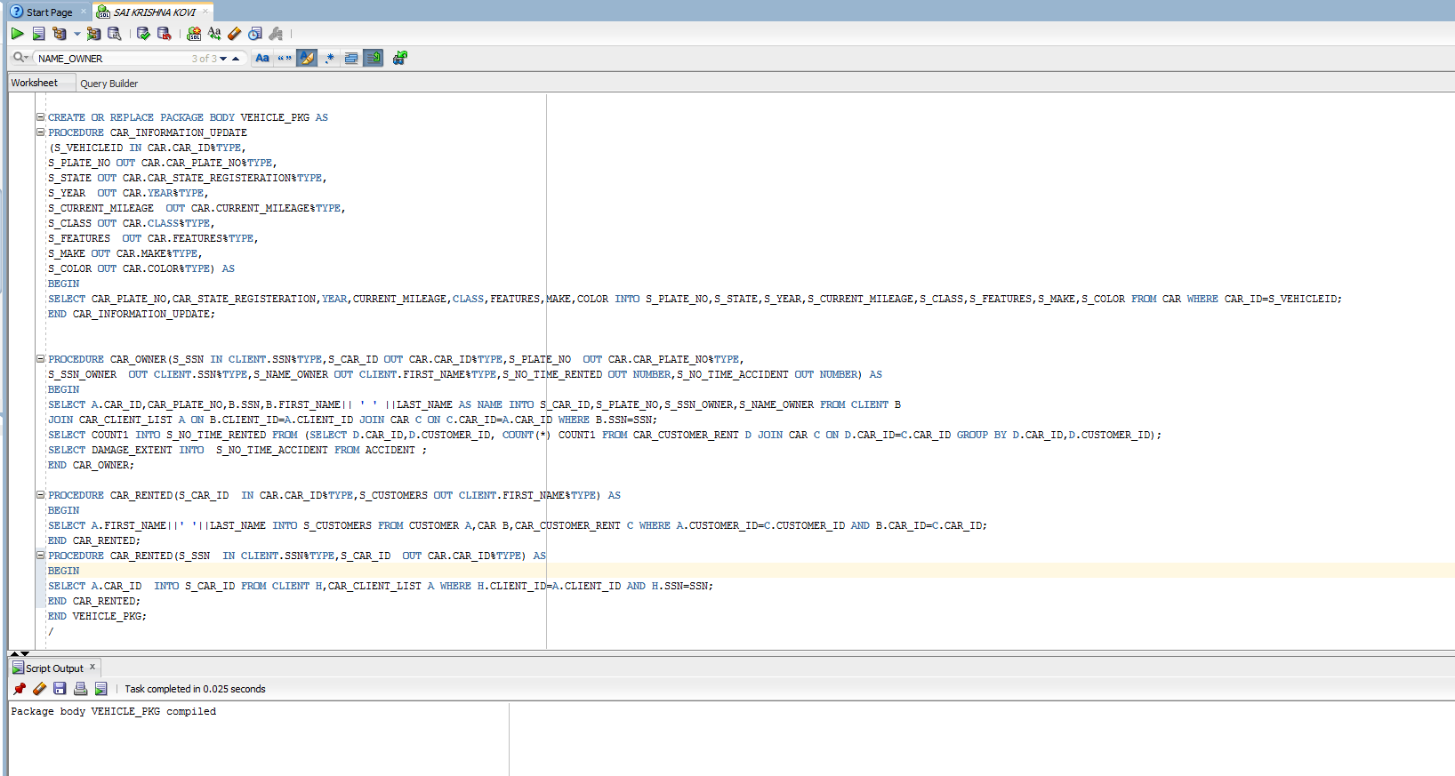

**15D. PACKAGE ACCIDENT_PKG**

**QUERY:**

**CREATE OR REPLACE PACKAGE ACCIDENT_PKG AS**

**PROCEDURE CAR_ACCIDENT_UPDATE(S_CAR_ID IN CAR.CAR_ID%TYPE,S_CUSTOMER_NAME OUT CUSTOMER.FIRST_NAME%TYPE,S_CUSTOMER_ADDRESS OUT CUSTOMER.STREET_ADDRESS%TYPE,**

**S_CUSTOMER_PHONE OUT CUSTOMER.CELL_PHONE%TYPE,S_DATE_AND_TIME OUT ACCIDENT.DATE_TIME%TYPE,S_LOCATION_ACCIDENT OUT ACCIDENT.LOCATION%TYPE, S_EXTENT_OF_DAMAGE OUT ACCIDENT.DAMAGE_EXTENT%TYPE,**

**S_COST_OF_DAMAGE OUT ACCIDENT.COST_DAMAGE%TYPE);**

**PROCEDURE CUSTOMER_ACCIDENT_UPDATE(S_SSN IN CUSTOMER.SSN%TYPE,S_ACCIDENT_REPORT OUT ACCIDENT.POLICE_REPORT%TYPE,S_SUMMARY_ACCIDENT OUT ACCIDENT.SUMMARY_POLICE_REPORT%TYPE);**

**END ACCIDENT_PKG;**

**/**

**SET SERVEROUTPUT ON;**

**CREATE OR REPLACE PACKAGE BODY ACCIDENT_PKG AS**

**PROCEDURE CAR_ACCIDENT_UPDATE(S_CAR_ID IN CAR.CAR_ID%TYPE,S_CUSTOMER_NAME OUT CUSTOMER.FIRST_NAME%TYPE,S_CUSTOMER_ADDRESS OUT CUSTOMER.STREET_ADDRESS%TYPE,**

**S_CUSTOMER_PHONE OUT CUSTOMER.CELL_PHONE%TYPE,S_DATE_AND_TIME OUT ACCIDENT.DATE_TIME%TYPE,S_LOCATION_ACCIDENT OUT ACCIDENT.LOCATION%TYPE, S_EXTENT_OF_DAMAGE OUT ACCIDENT.DAMAGE_EXTENT%TYPE,**

**S_COST_OF_DAMAGE OUT ACCIDENT.COST_DAMAGE%TYPE) AS**

**BEGIN**

**SELECT A.FIRST_NAME||' '||LAST_NAME,A.STREET_ADDRESS,A.CELL_PHONE,B.DATE_TIME,B.LOCATION,B.DAMAGE_EXTENT,B.COST_DAMAGE INTO S_CUSTOMER_NAME,S_CUSTOMER_ADDRESS,S_CUSTOMER_PHONE,S_DATE_AND_TIME,S_LOCATION_ACCIDENT,**

**S_EXTENT_OF_DAMAGE,S_COST_OF_DAMAGE FROM CUSTOMER A,ACCIDENT B WHERE A.CUSTOMER_ID=B.CUSTOMER_ID AND CAR_ID=CAR_ID;**

**END CAR_ACCIDENT_UPDATE;**

**PROCEDURE CUSTOMER_ACCIDENT_UPDATE(S_SSN IN CUSTOMER.SSN%TYPE,S_ACCIDENT_REPORT OUT ACCIDENT.POLICE_REPORT%TYPE,S_SUMMARY_ACCIDENT OUT ACCIDENT.SUMMARY_POLICE_REPORT%TYPE) AS**

**BEGIN**

**SELECT A.POLICE_REPORT,A.SUMMARY_POLICE_REPORT INTO S_ACCIDENT_REPORT,S_SUMMARY_ACCIDENT FROM ACCIDENT A, CUSTOMER B WHERE B.SSN=SSN;**

**END;**

**END ACCIDENT_PKG;**

**/**

**Output:**

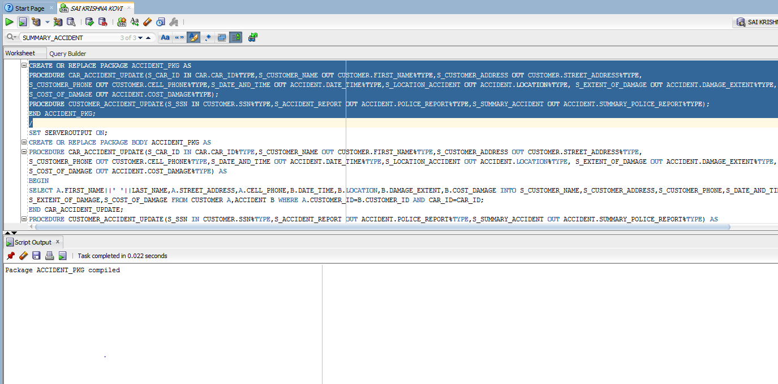

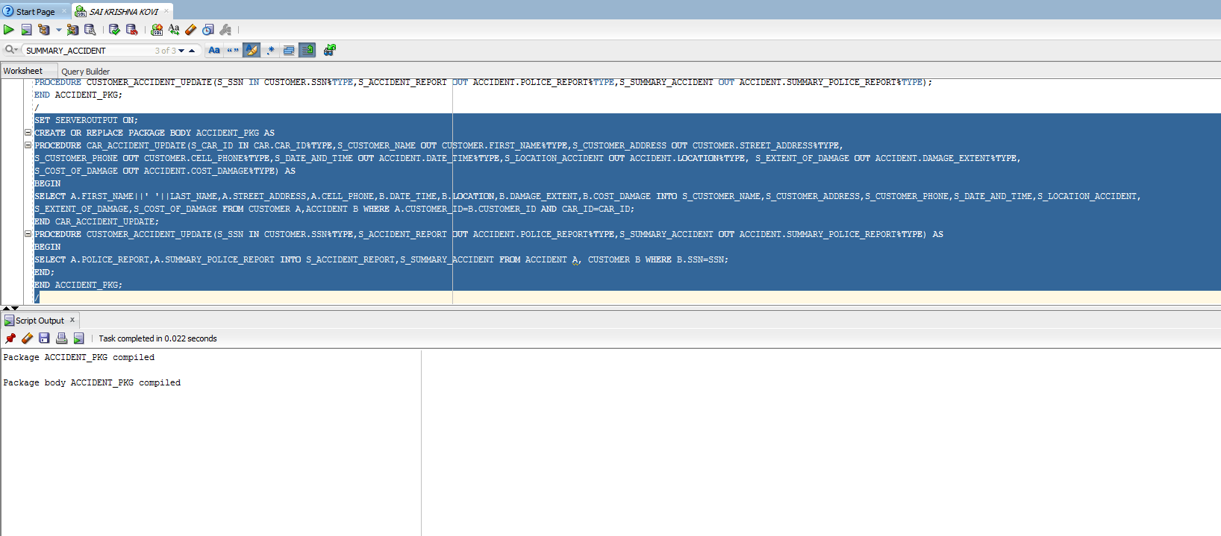

**15F GEN_MANAGER**

**QUERY:**

**CREATE OR REPLACE PROCEDURE GEN_MANAGER AS**

**S_BRANCH_ID NUMBER(10);**

**S_BRANCH_NAME VARCHAR2(15);**

**S_MANAGER_NAME VARCHAR2(20);**

**S_MANAGER_HIRED DATE;**

**CURSOR BRANCH_CURSOR IS**

**SELECT OFFICE_ID,NAME,GENERAL_MGR_ID,DATE_HIRED FROM BRANCH_INFO;**

**BEGIN**

**OPEN BRANCH_CURSOR;**

**LOOP**

**FETCH BRANCH_CURSOR INTO S_BRANCH_ID,S_BRANCH_NAME,S_MANAGER_NAME,S_MANAGER_HIRED;**

**EXIT WHEN BRANCH_CURSOR%NOTFOUND;**

**DBMS_OUTPUT.PUT_LINE('BRANCH_ID COMES AS :'||S_BRANCH_ID);**

**DBMS_OUTPUT.PUT_LINE('BRANCH_OFFICE COMES AS:'||S_BRANCH_NAME);**

**DBMS_OUTPUT.PUT_LINE('GENERALMANAGER_NAME COMES AS:'||S_MANAGER_NAME);**

**DBMS_OUTPUT.PUT_LINE('MANAGER_HIRED COMES AS:'||S_MANAGER_HIRED);**

**END LOOP;**

**CLOSE BRANCH_CURSOR;**

**END;**

**/**

**OUTPUT:**

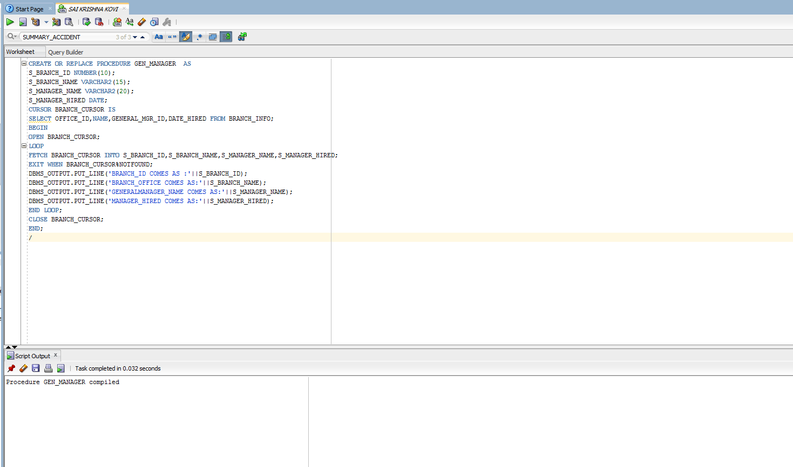

**16.TRIGGERS**

**16G. EMPLOYEE_HISTORY:**

**QUERY:**

**CREATE TABLE EMPLOYEE_HISTORY AS SELECT * FROM PROJECT.EMPLOYEE;**

**CREATE OR REPLACE TRIGGER EMPLOYEE_HISTORY**

**AFTER DELETE ON EMPLOYEE**

**for each row**

**BEGIN**

**INSERT INTO EMPLOYEE_HISTORY(EMPLOYEE_ID,FIRST_NAME,LAST_NAME,MIDDLE_NAME,STREET_ADDRESS,CITY,STATE,ZIP_CODE,SSN,SALARY,TAX_DEDUCTION,BIRTH_DATE,GENDER,MARITAL_STATUS,**

**SPOUSE_NAME,LAST_DEGREE,DATE_DEGREE,NO_OF_DEPENDENTS,HOME_PHONE_NUMBER,CELL_PHONE_NUMBER)**

**VALUES(:old.EMPLOYEE_ID,:OLD.FIRST_NAME,:OLD.LAST_NAME,:OLD.MIDDLE_NAME,:OLD.STREET_ADDRESS,:old.CITY,:old.STATE,:OLD.ZIP_CODE,:old.SSN,:OLD.SALARY,:OLD.TAX_DEDUCTION,**

**:OLD.BIRTH_DATE,:OLD.GENDER,:OLD.MARITAL_STATUS,:OLD.SPOUSE_NAME,:OLD.LAST_DEGREE,:OLD.DATE_DEGREE,:OLD.NO_OF_DEPENDENTS,:OLD.HOME_PHONE_NUMBER,:OLD.CELL_PHONE_NUMBER);**

**END;**

**DELETE FROM EMPLOYEE WHERE EMPLOYEE_ID = 56478 ;**

**SELECT * FROM EMPLOYEE_HISTORY;**

**OUTPUT:**

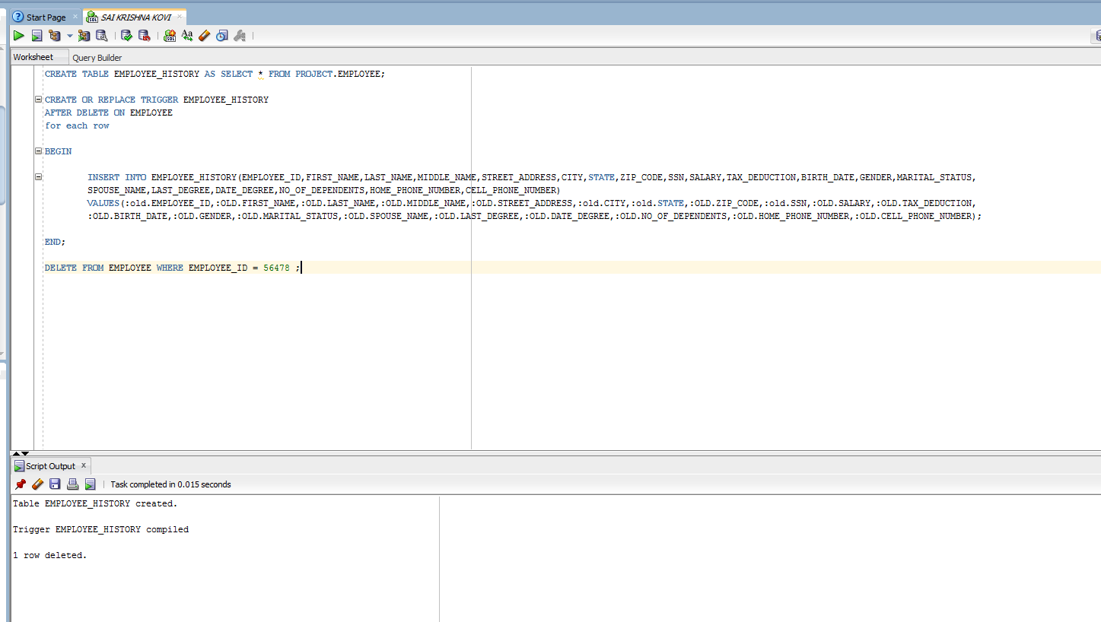

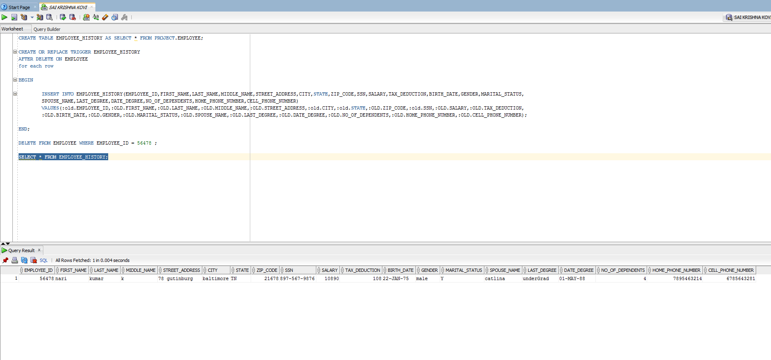

**16H.TRIGGERS CUSTOMER_LOG:**

**QUERY:**

**CREATE TABLE CUSTOMER_LOG AS SELECT * FROM PROJECT.CUSTOMER;**

**CREATE OR REPLACE TRIGGER CUSTOMER_LOG**

**AFTER UPDATE ON CUSTOMER**

**for each row**

**BEGIN**

**INSERT INTO CUSTOMER_LOG(CUSTOMER_ID,FIRST_NAME,LAST_NAME,MIDDLE_INITIAL,BIRTH_DATE,cell_phone,**

**STREET_ADDRESS,CITY,STATE,ZIP_CODE,EMAIL,LICENSE_ISSUED_STATE,**

**LICENSE_NUMBER,CREDIT_CARD_NUMBER,EXPIRATION_DATE,SSN)**

**VALUES(:OLD.CUSTOMER_ID,:OLD.FIRST_NAME,:OLD.LAST_NAME,:OLD.MIDDLE_INITIAL,:OLD.BIRTH_DATE,:OLD.CELL_PHONE,**

**:OLD.STREET_ADDRESS,:OLD.CITY,:OLD.STATE,:OLD.ZIP_CODE,:OLD.EMAIL,:OLD.LICENSE_ISSUED_STATE,**

**:OLD.LICENSE_NUMBER,:OLD.CREDIT_CARD_NUMBER,:OLD.EXPIRATION_DATE,:OLD.SSN);**

**INSERT INTO CUSTOMER_LOG(CUSTOMER_ID,FIRST_NAME,LAST_NAME,MIDDLE_INITIAL,CELL_PHONE,BIRTH_DATE,**

**STREET_ADDRESS,CITY,STATE,ZIP_CODE,EMAIL,LICENSE_ISSUED_STATE,**

**LICENSE_NUMBER,CREDIT_CARD_NUMBER,EXPIRATION_DATE,SSN)**

**VALUES(:NEW.CUSTOMER_ID,:NEW.FIRST_NAME,:NEW.LAST_NAME,:NEW.MIDDLE_INITIAL,:NEW.CELL_PHONE,:NEW.BIRTH_DATE,**

**:NEW.STREET_ADDRESS,:NEW.CITY,:NEW.STATE,:NEW.ZIP_CODE,**

**:NEW.EMAIL,:NEW.LICENSE_ISSUED_STATE,:NEW.LICENSE_NUMBER,:NEW.CREDIT_CARD_NUMBER,:NEW.EXPIRATION_DATE,:NEW.SSN);**

**END CUSTOMER_LOG;**

**UPDATE CUSTOMER SET FIRST_NAME='WILSON' WHERE CUSTOMER_ID =1006;**

**OUTPUT:**

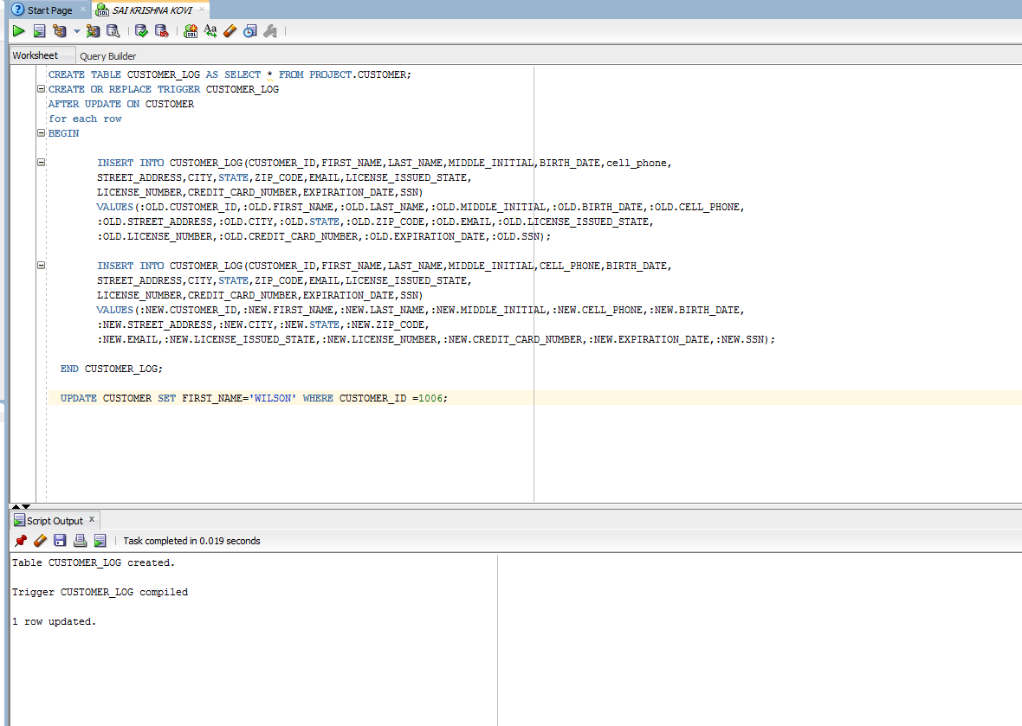

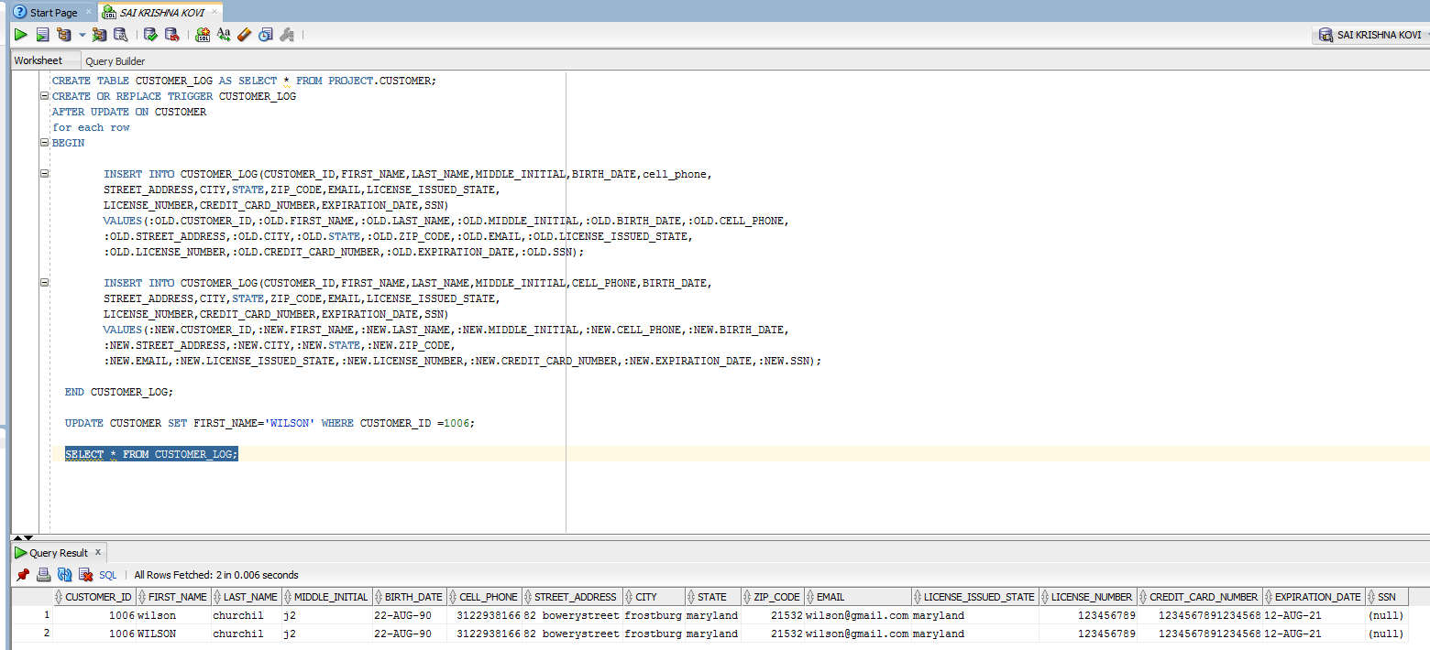

**16i.ACCIDENT_LOG:**

**Query:**

**CREATE TABLE ACCIDENT_LOG (EMP_NAME VARCHAR2(25),CUSTOMER_NAME VARCHAR(20),ACCIDENT_DATE TIMESTAMP);**

**CREATE OR REPLACE TRIGGER ACCIDENT_LOG AFTER INSERT ON ACCIDENT FOR EACH ROW**

**DECLARE**

**V_EMP_NAME NUMBER;**

**V_CUST_NAME VARCHAR2(20);**

**BEGIN**

**SELECT C.FIRST_NAME ||' '||C.LAST_NAME INTO V_EMP_NAME FROM CAR_CLIENT_LIST A,PROJECT.EMPLOYEE_CAR_LIST B,PROJECT.EMPLOYEE C WHERE A.CAR_ID =:NEW.CAR_ID AND B.CAR_ID=A.CAR_ID AND B.EMPLOYEE_ID=C.EMPLOYEE_ID;**

**SELECT A.FIRST_NAME||' '||A.LAST_NAME INTO V_CUST_NAME FROM CUSTOMER A WHERE A.CUSTOMER_ID=:NEW.CUSTOMER_ID;**

**INSERT INTO ACCIDENT_LOG VALUES(V_EMP_NAME,V_CUST_NAME,:NEW.DATE_TIME);**

**END ACCIDENT_LOG;**

**Output:**

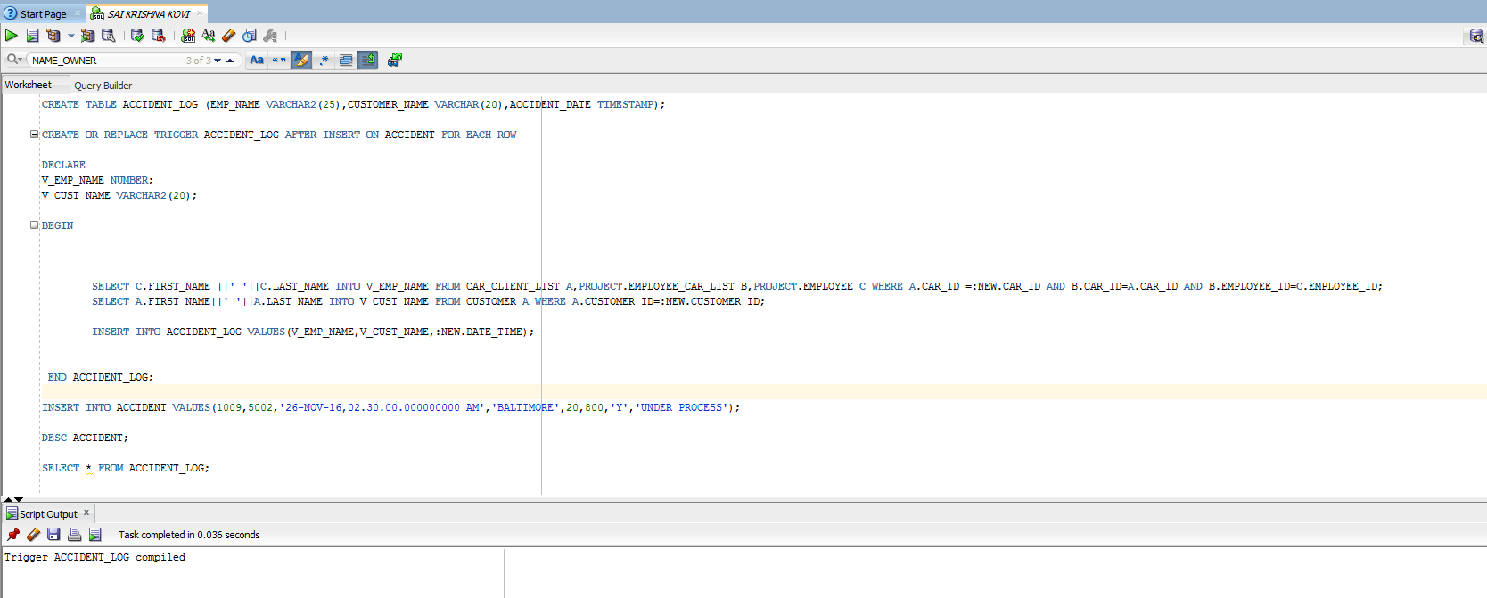

**17.TABLE ERROR_LOG**

**OUTPUT:**

**Create table ERROR_LOG**

**(**

**TABLE_NAME VARCHAR2(30),**

**TRIGGER_NAME VARCHAR2(40),**

**ERROR_DATE TIMESTAMP(6),**

**TRIGGER_EVENT VARCHAR2(60),**

**TRIGGER_TYPE VARCHAR2(25)**

**);**

**SELECT *FROM ERROR_LOG;**

**Output:**

